Subscription Administrator User Guide

Table of Contents

**ABOUT THIS GUIDE** **1**

**INTRODUCTION** **2**

**1 GETTING STARTED** **3**

1.1 User Login 3

1.2 Security Questions 4

1.3 Change Password 5

1.4 Reset Password 6

**2 HOME PAGE 7**

2.1 Navigation Panel 7

2.2 Sidebar 8

**3 DASHBOARD PAGE 9**

3.1 Dashboard 9

**4 SUBSCRIPTION PAGE 11**

4.1 Customer 11

4.2 Users 13

4.3 Machine 13

4.4 Licence 15

4.5 App 17

4.6 Functional flow 18

**5 REPORTS PAGE 20**

5.1 Report 20

5.2 Orders 21

5.3 Functional flow 22

**6 LOCATION PAGE 23**

5.1 Map 23

**7 CALENDAR PAGE 24**

7.1 Event Calendar 24

**ABOUT THIS GUIDE**

This guide has been developed to guide you through the SubscriptionApp features concise and step-by-step method of instructions. This guide is intended to use by system administrators.

**INTRODUCTION**

Subscription App is an application which provides opportunities for IT administrators to maintain the record of all licenses created. This application enables users to create customer, machine IDs, licenses, manage licence details and download spreadsheets of the reports. It also includes the collection of information including start Date, expiry Date, location in calendar and Map formats.

**1** **GETTING STARTED**

**1.1 User Login**

To login, browse to the Subscription interface at:

[http://<local IP address / host name>](http://servername)

Next, enter the default **username/password** combination of **admin1/1** which was set during installation.

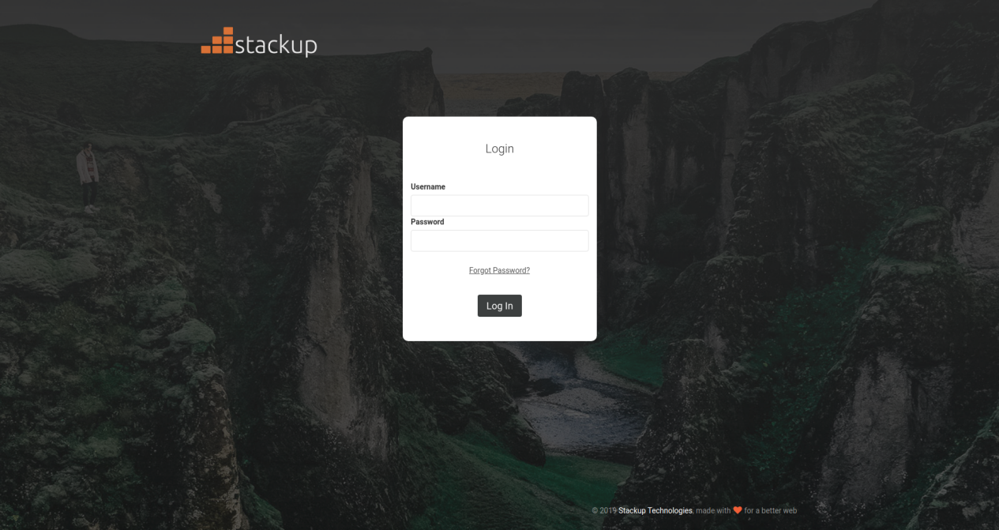

**1.2 Security Questions**

If user log in for the first time the **Security Question** screen displays.

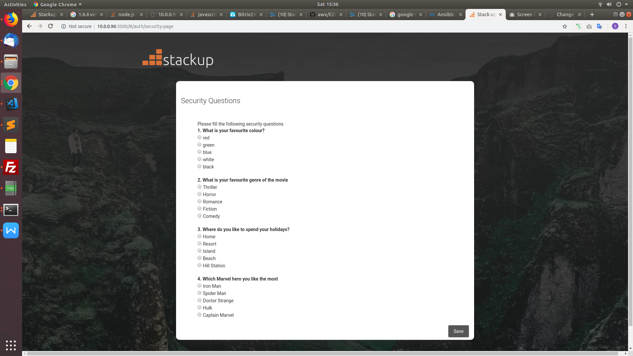

* Fill all the four listed security questions.
* Click **Save**. The Save button will not activate until the user answers all the four security questions.
* It redirects to Change Password page.

**1.3 Change Password**

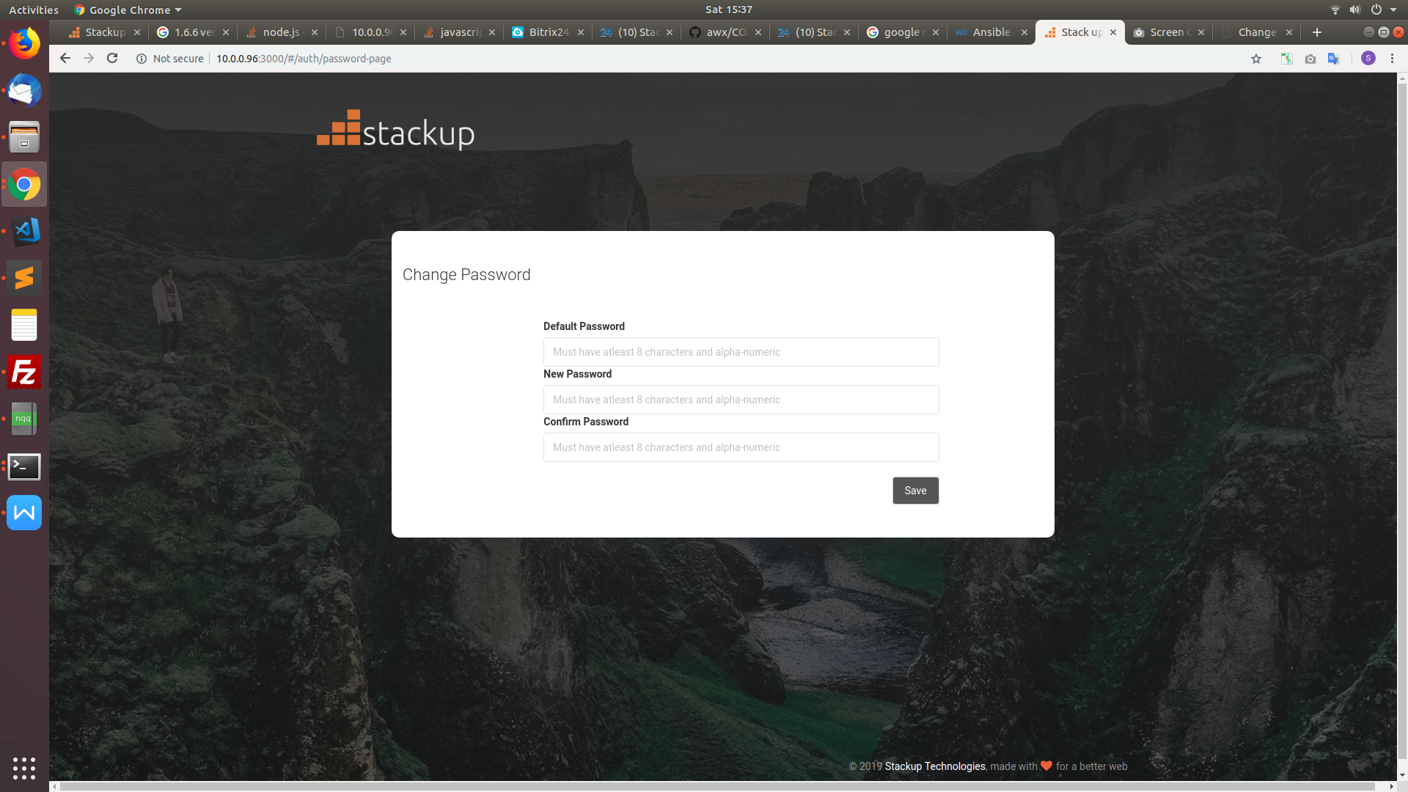

To change the password, do the following:

* Enter the old password in the **Old Password** Field.
* Enter a new password in the **New Password** and **Confirm Password** fields. The password is case sensitive and must match in both fields.
* Click **Save** to complete the login process.
* It redirects to login screen

**1.4 Reset Password**

If user forgets the password, do the following:

* Navigate to the Stackup login screen.
* Click **Forgot Password?**
* Enter the username, and click **Save**.

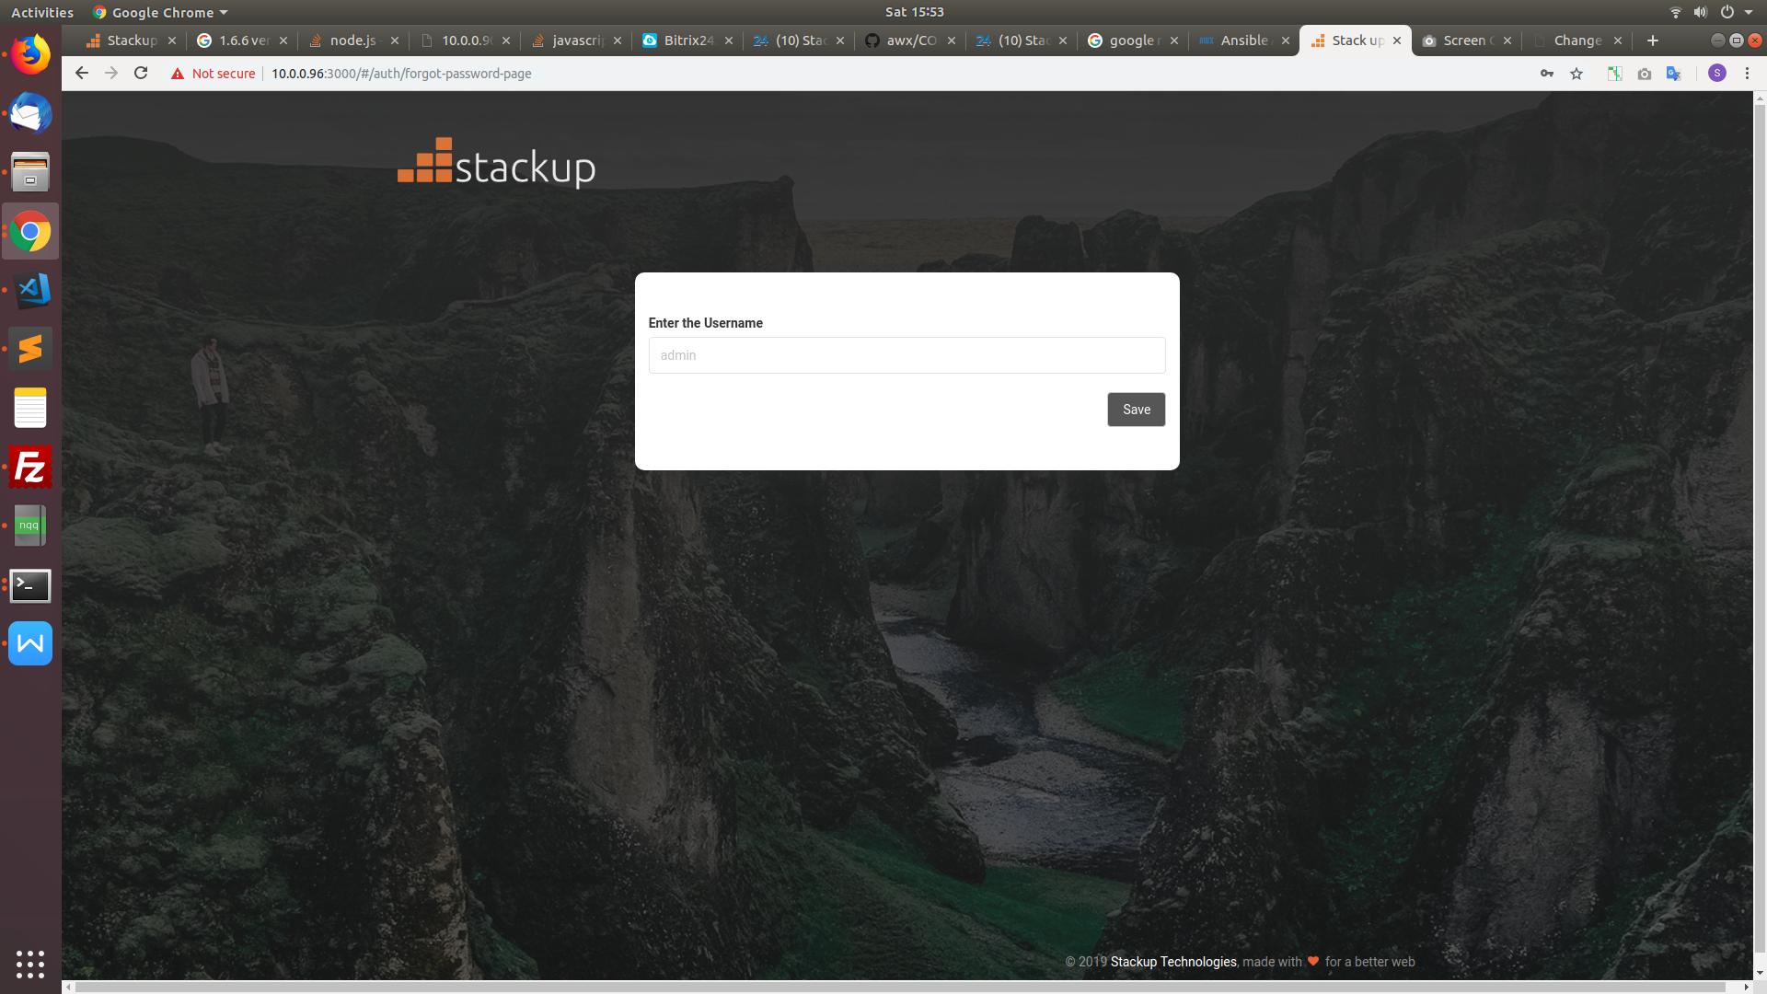

* You will be prompted to answer all the four security questions which you had set up previously. Answer the questions, and click **Save**.
* Now Reset the password

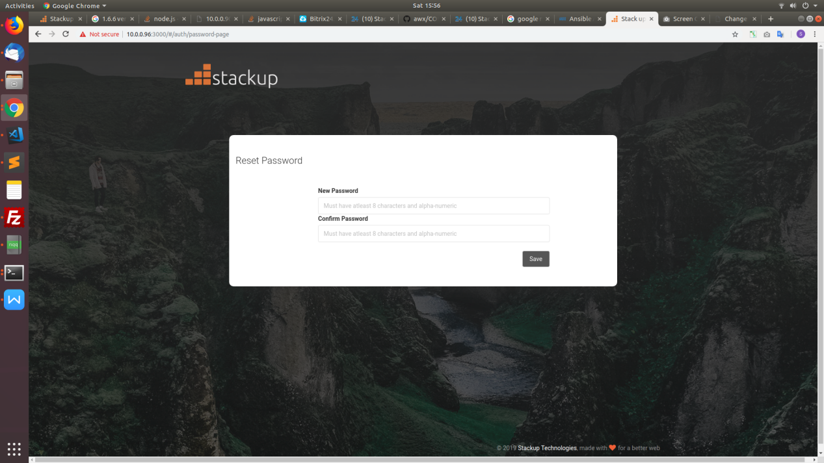

* Click save. It redirects to login screen

**2** **HOME PAGE**

The home screen by default contains two portions: the navigation panel and the sidebar.

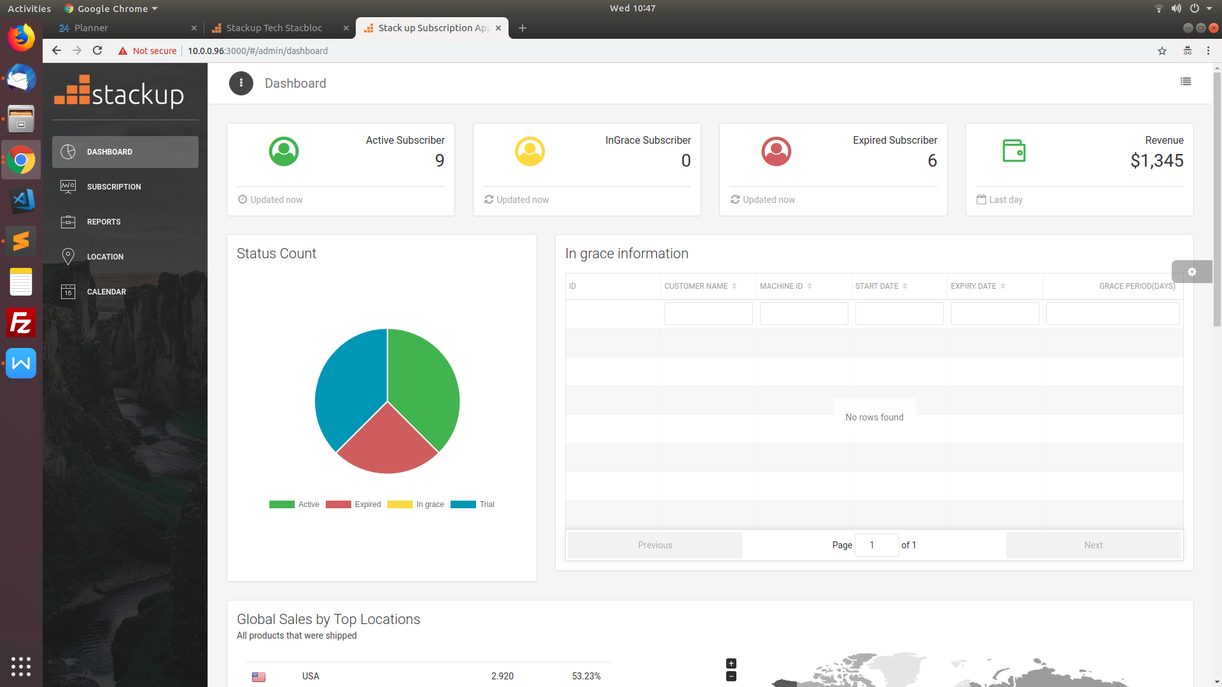

**2.1 Navigation Panel**

On the top of the navigation panel menu icon contains two options in the form of drop down which includes change password and logout

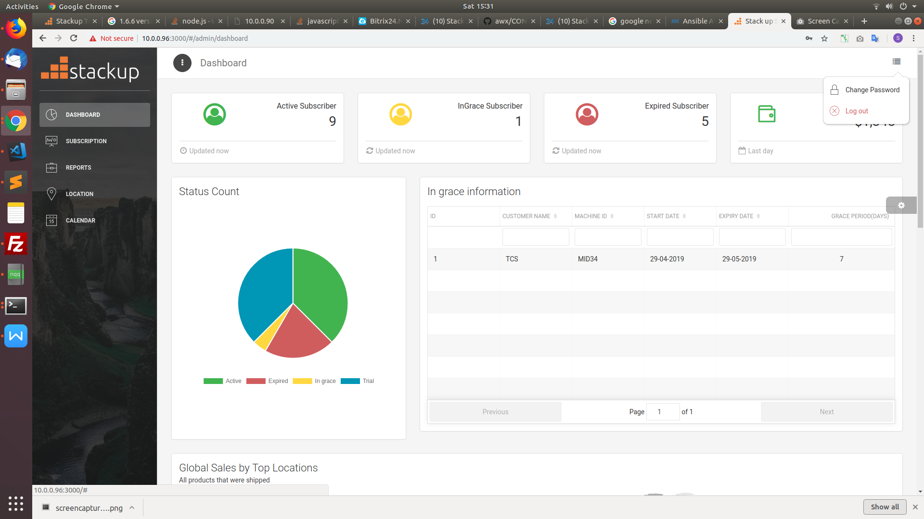

* Change Password

On Click of Change Password icon redirects user to Change password page.

* To logout,

On click the **Logout** icon the user gets logged out.

**2.2 Side Bar**

On the left side of the UI is the side bar. It allows the user to view the content and activities in a streamlined way.

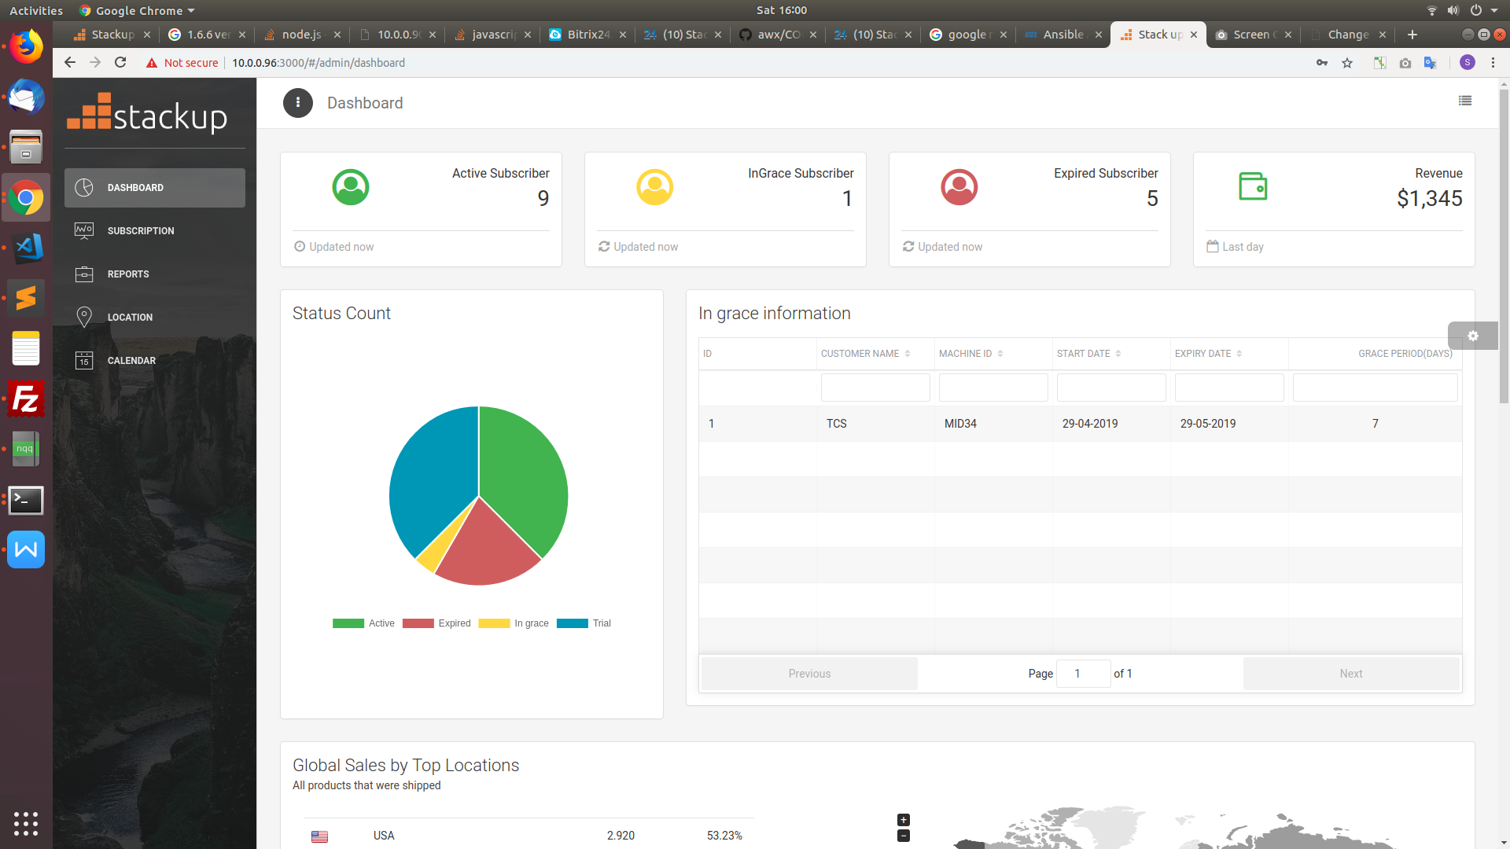

**3 DASHBOARD PAGE**

**3.1 Dashboard**

The dashboard gives over view in a pictorial representation.



* It gives a quick overview of the count of Active , expired , In grace statuses of the licenses in card format.

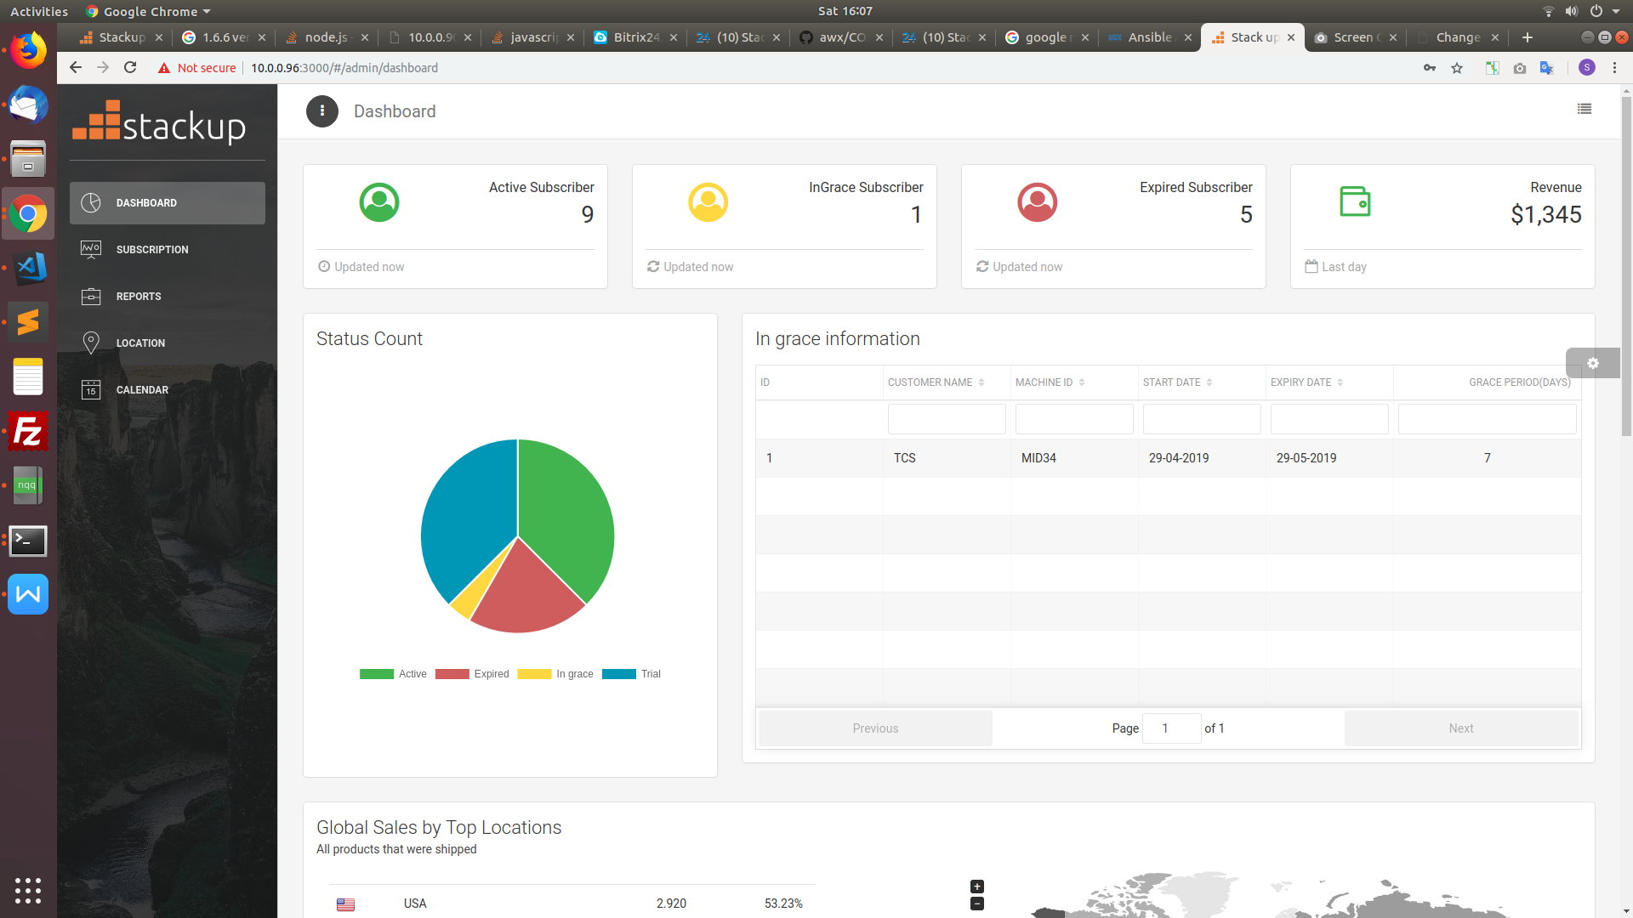

* It also shows the statistical data of licence status in table and pie chart.



* It depicts the order start date count which is used for sales in bar chart

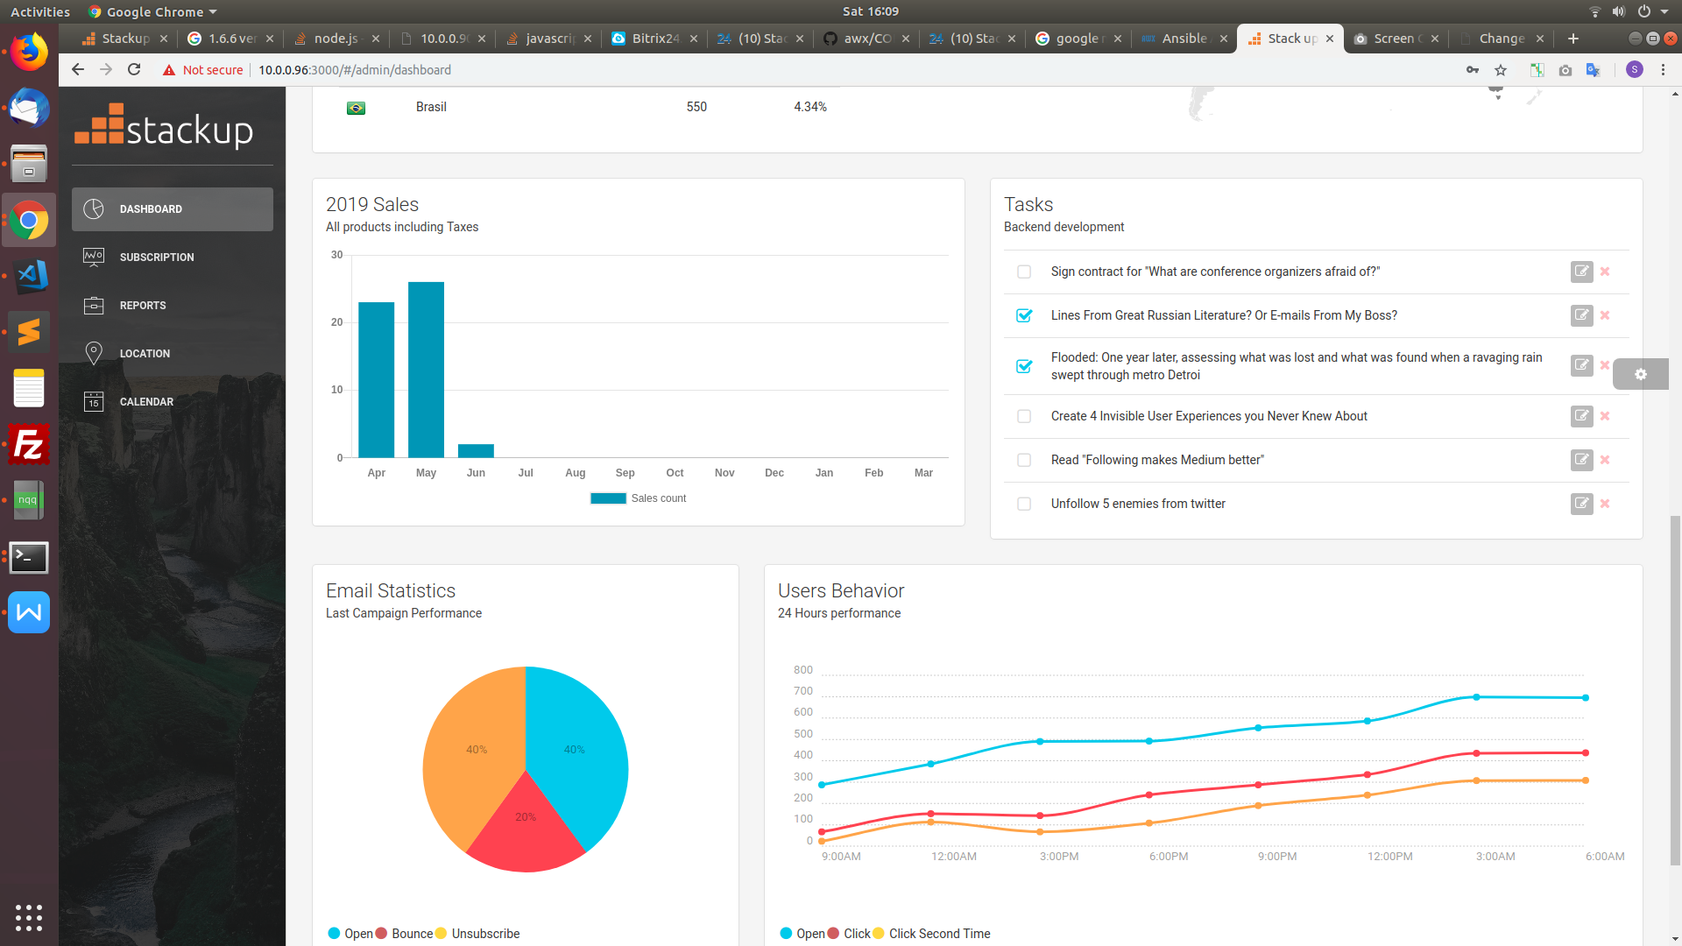

**4** **SUBSCRIPTION PAGE**

This page consists of 5 tabs in tabular format which allows user to view activities specifically.

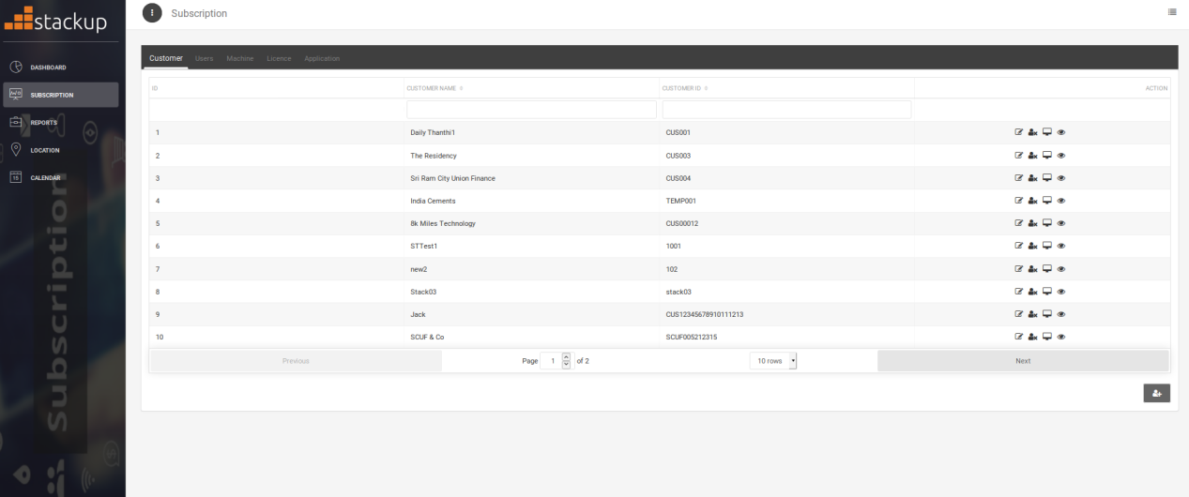

**4.1 Customer Tab**

This tab consists of data of the Customer Name , Customer Id and actions to be performed in a table format.

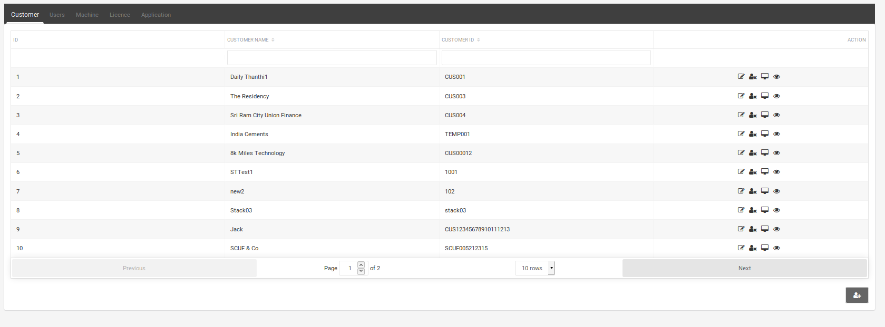

**Actions**

This page allows users to perform three actions namely **Edit, Delete** and **Machine Details**.

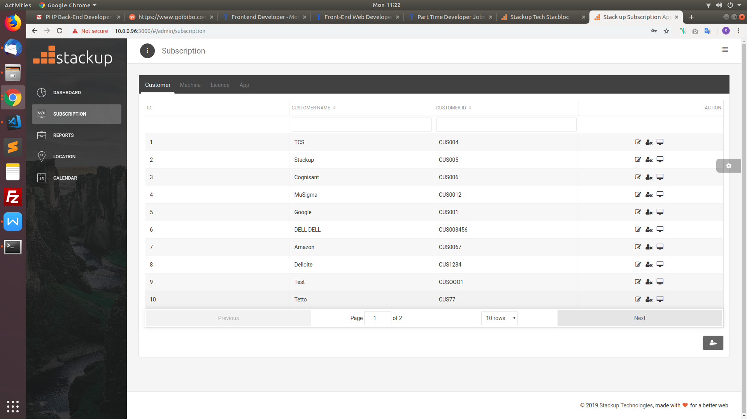

* Edit -

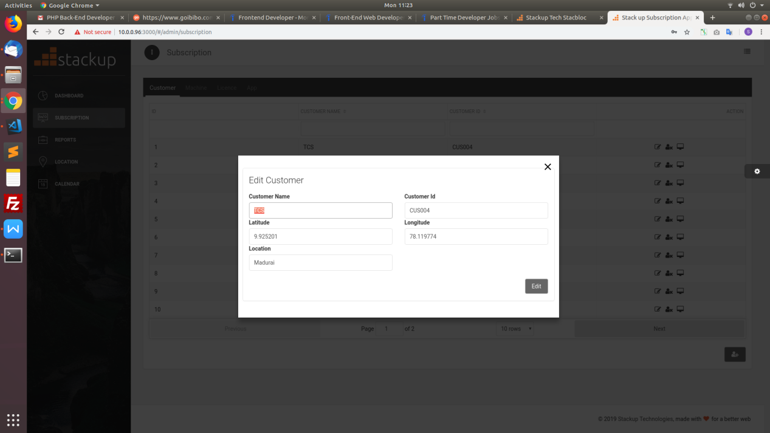

User can edit all details of Customer Name,Customer ID, latitude, longitude and location details.

* Delete -

User can delete customer details just by giving confirmation to alert.

* Machine Details-

User can get specific customer’s machine ID details.

**Adding customer information:**



User can add customer details on click of plus button.

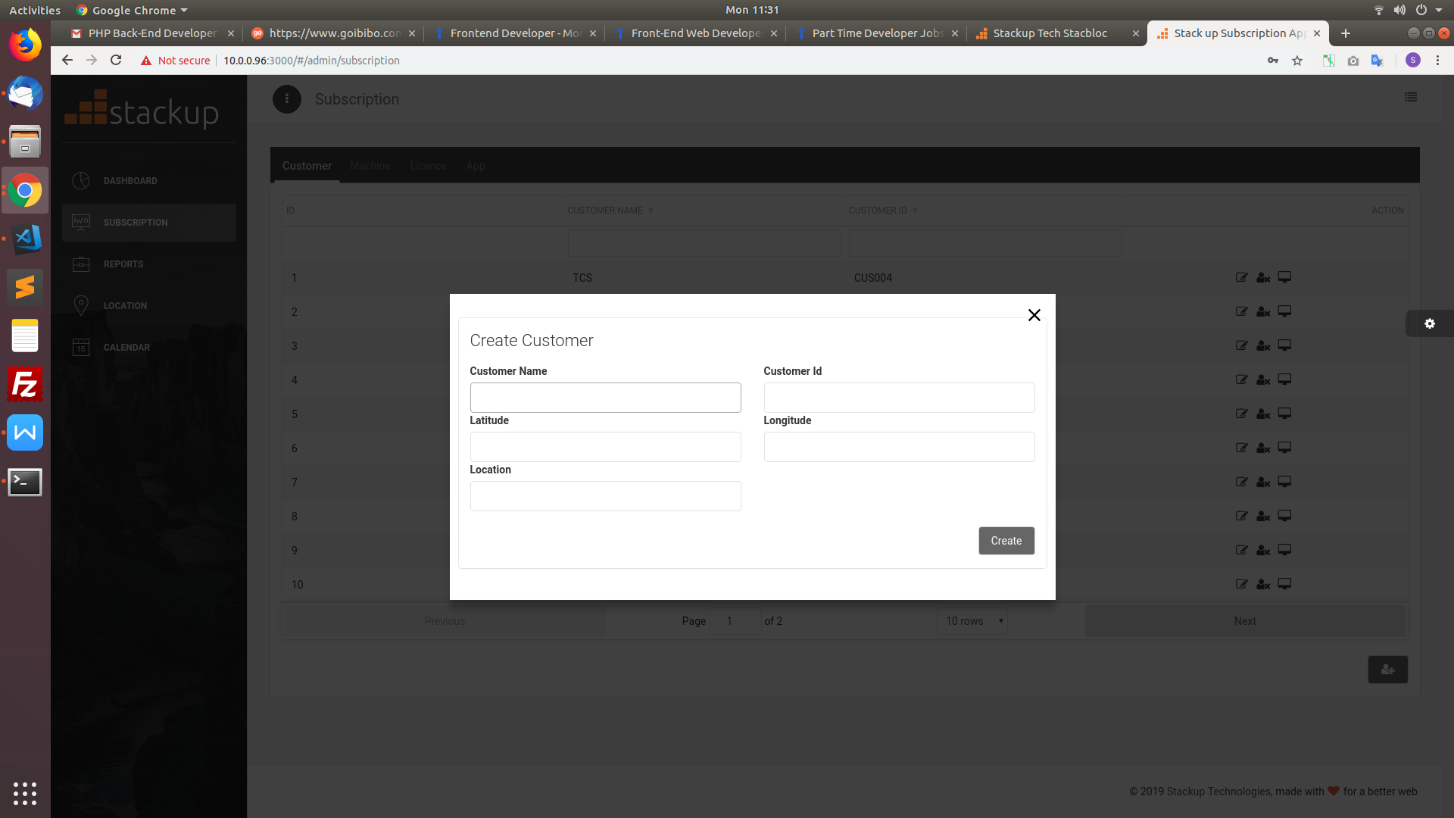

Click create button after filling the details.

**4.2 Users Tab**

This tab consists of data of the users corresponding to the particular Client , shows the username and email id of two users corresponding to that particular client.

It provides option for creating, editing, activate/deactivate and delete the user 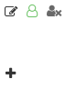

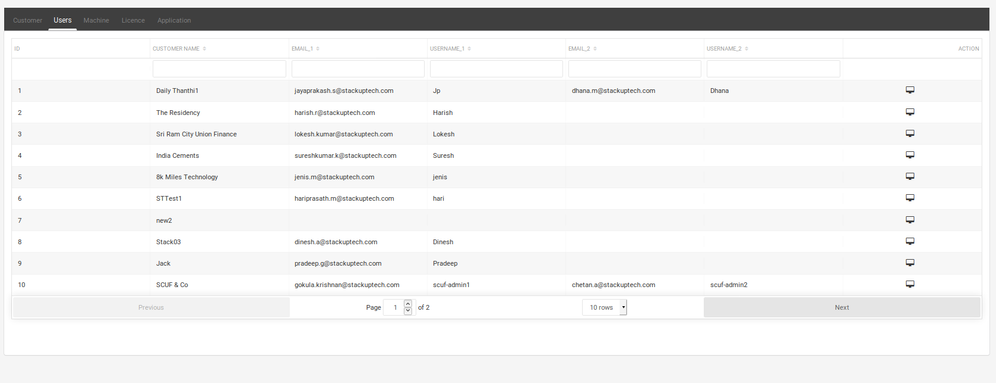

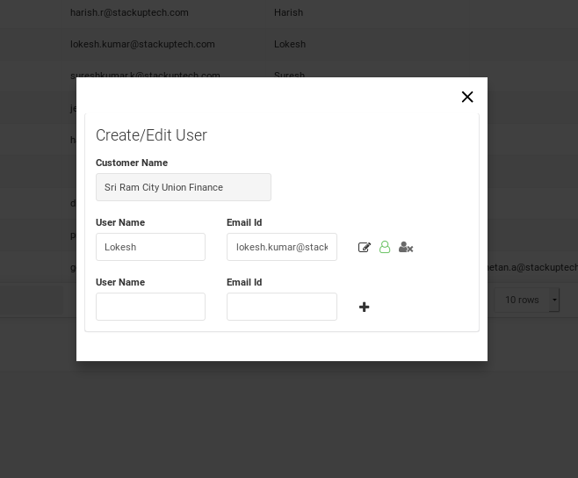

**4.3 Machine Tab**

This tab consists of data of the Customer Name , corresponding Machine IDs and actions to be performed in a table format.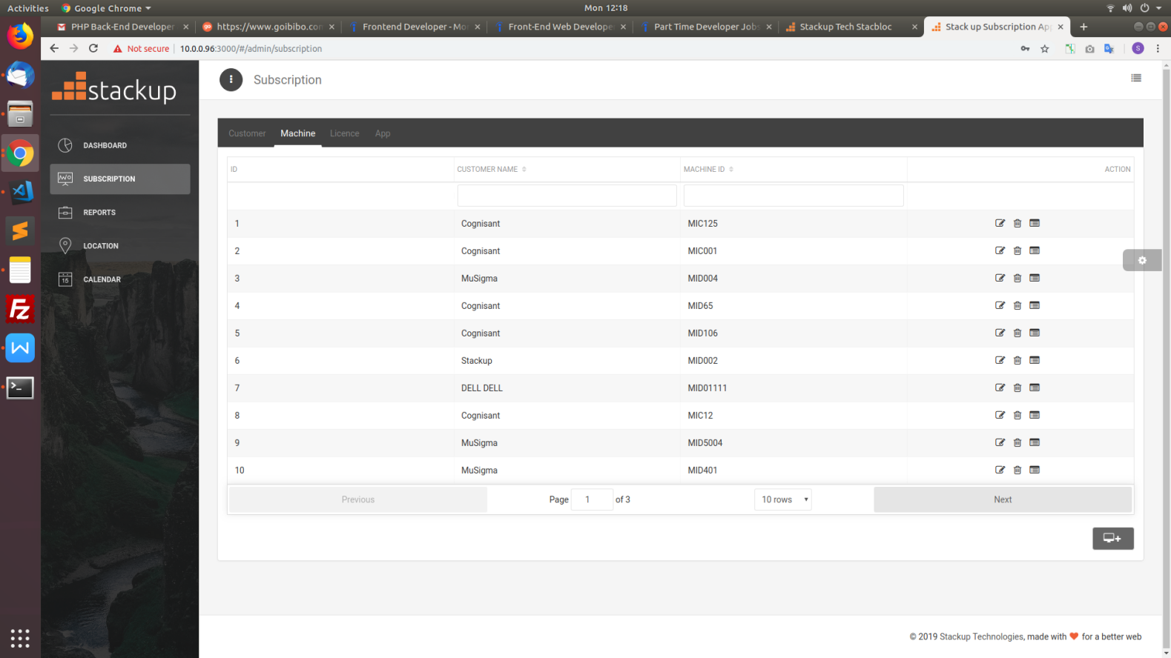

**Actions**

This page allows users to perform three actions namely **Edit, Delete** and **Subscription Details**.

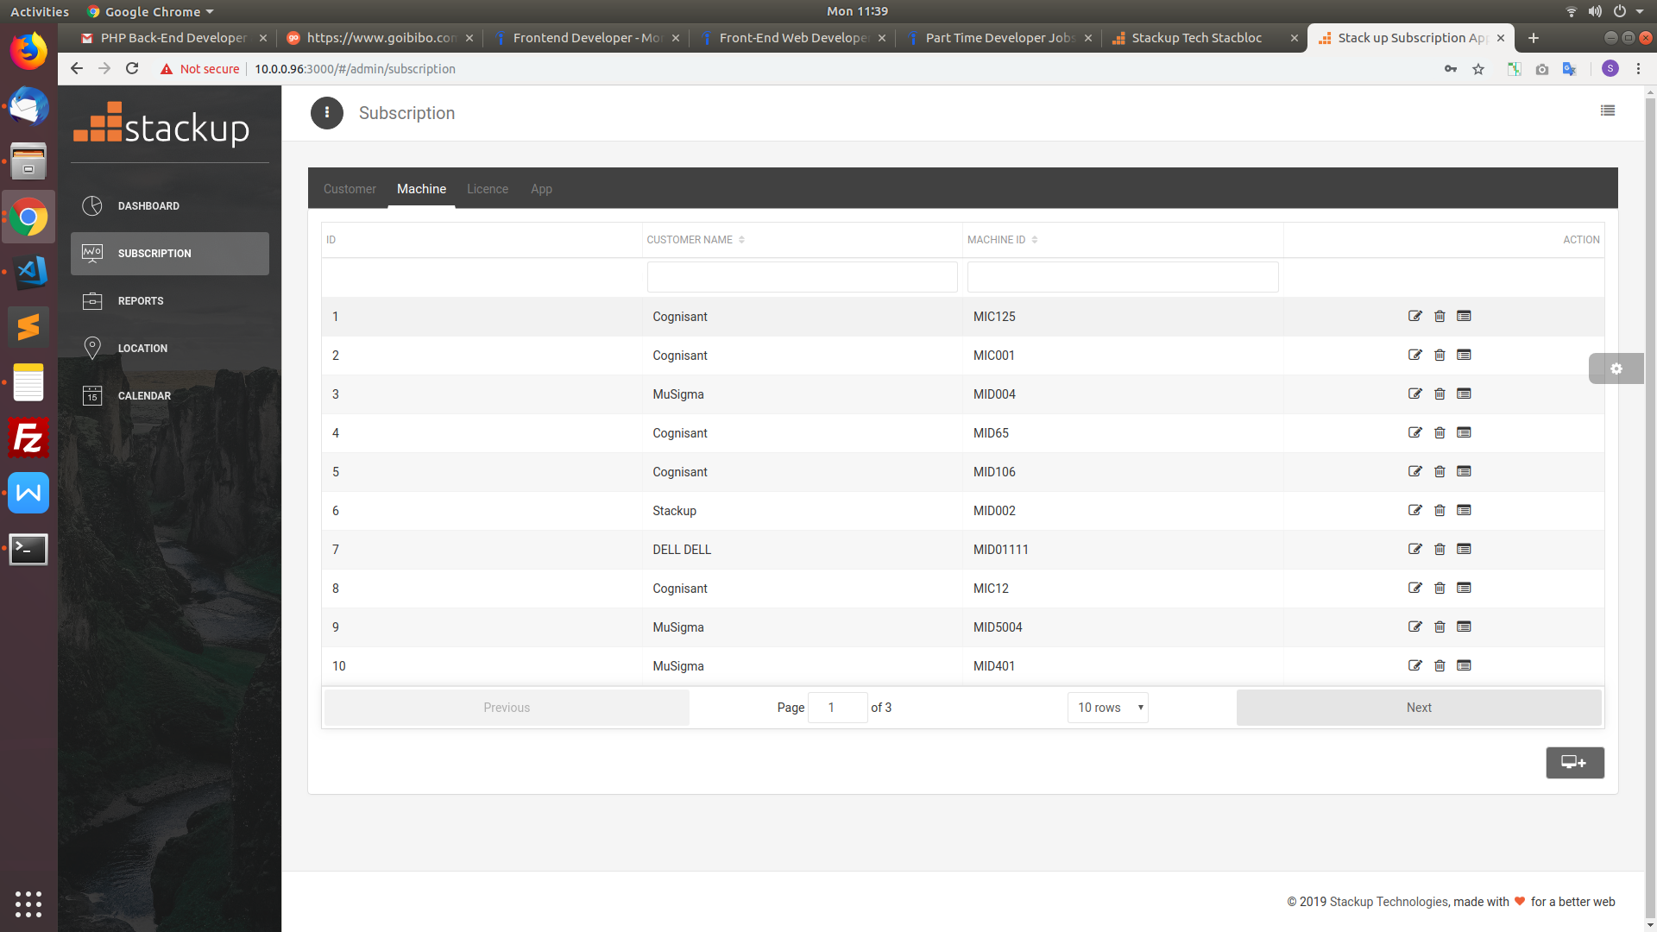

* Edit -

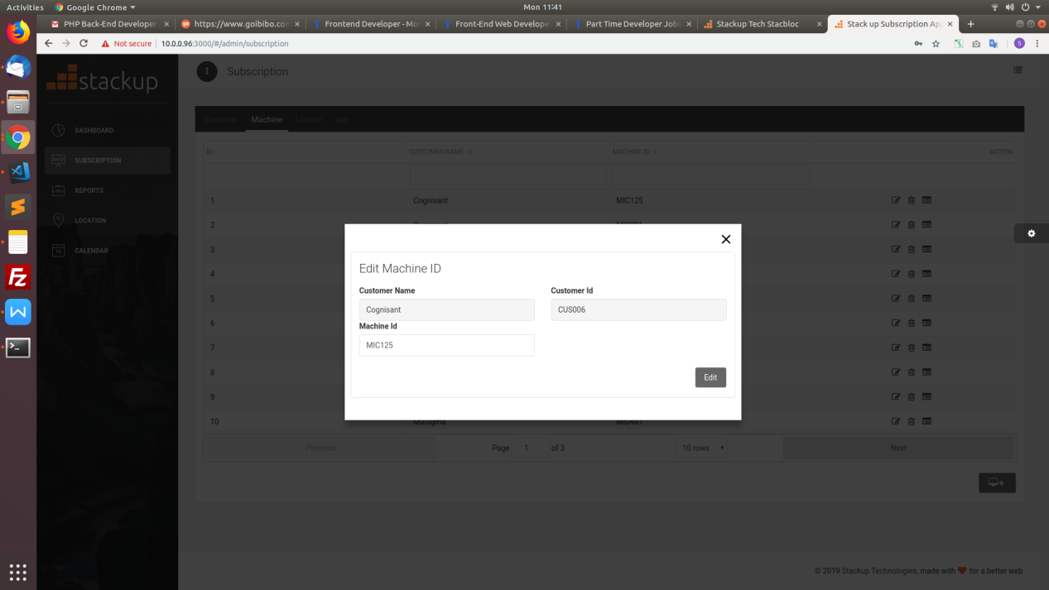

User can edit only machine ID details of the respective customer

* Delete -

User can delete machine ID just by giving confirmation to alert.

* Subscription Details-

User can get specific Subscription details of the corresponding machine ID

**Adding Machine ID information:**



User can add Machine ID details on click of plus button.

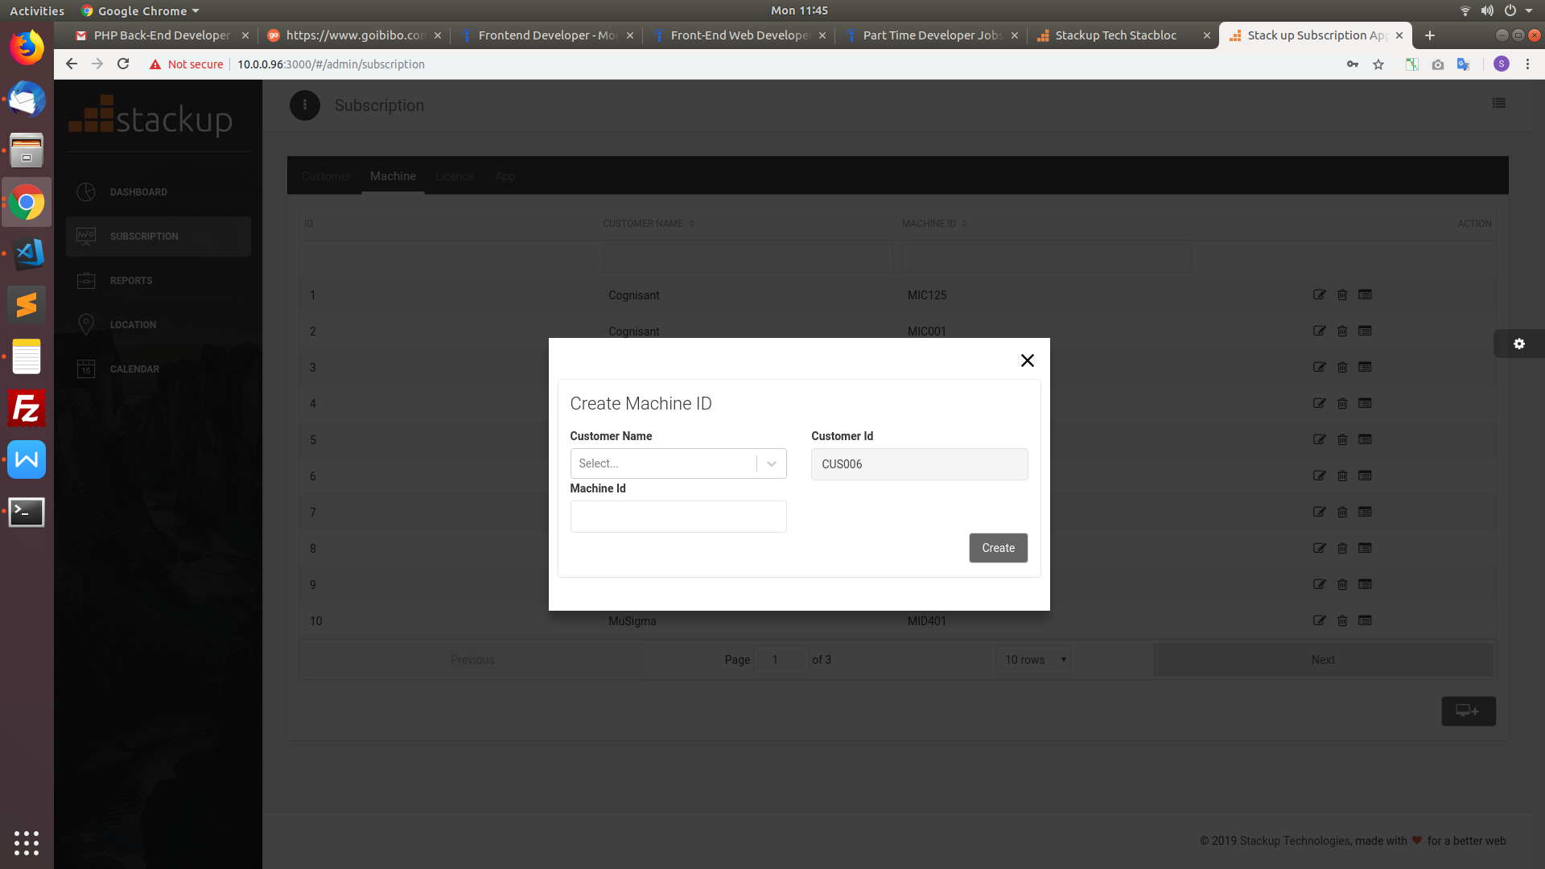

Click create button after filling machine ID and customer name details.

**4.4 Licence Tab**

This tab consists of data of the Customer Name , Machine ID, Application Name, Start date, Renewal Date, Expiry Date, Grace Period, Status and actions to be performed in a table format.

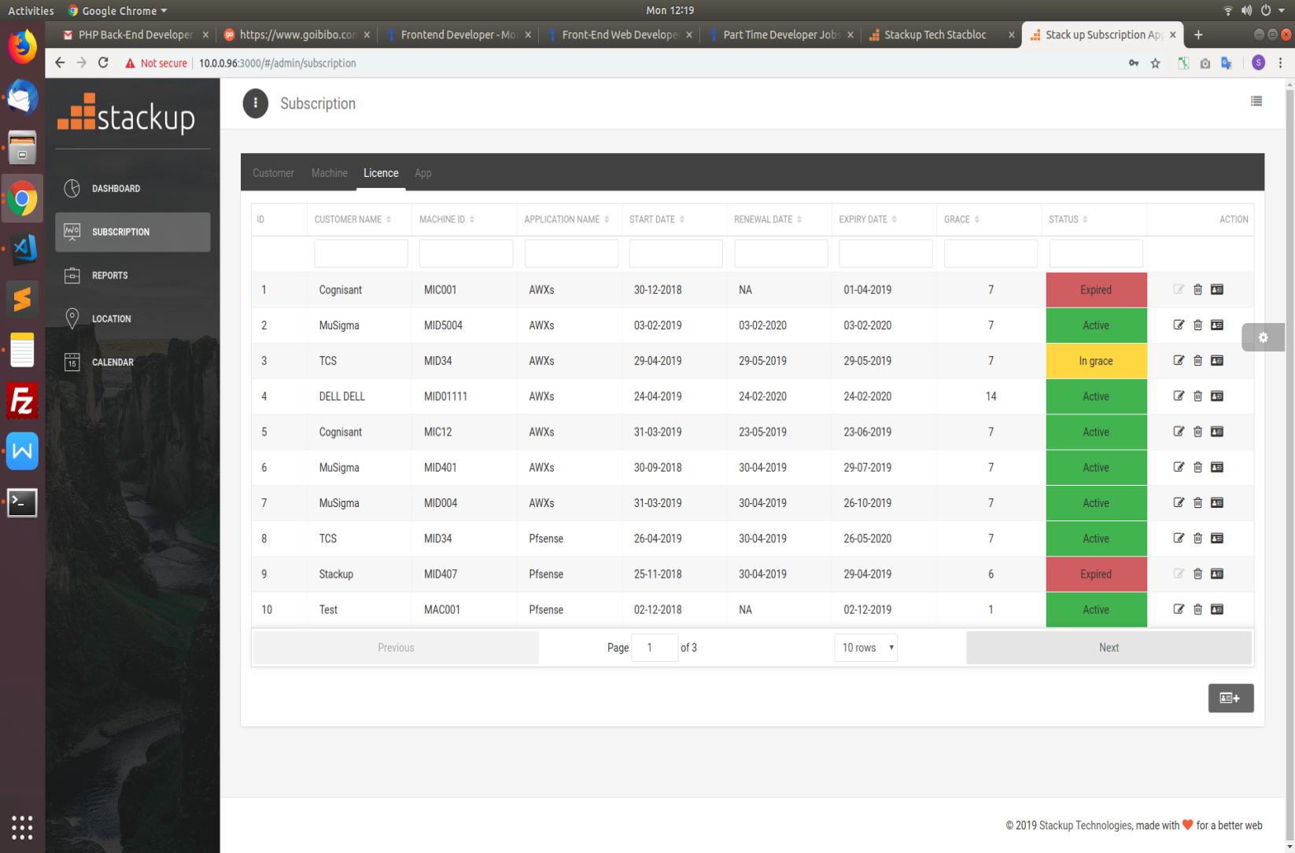

**Actions**

This page allows users to perform three actions namely **Edit, Delete** and **Renew**

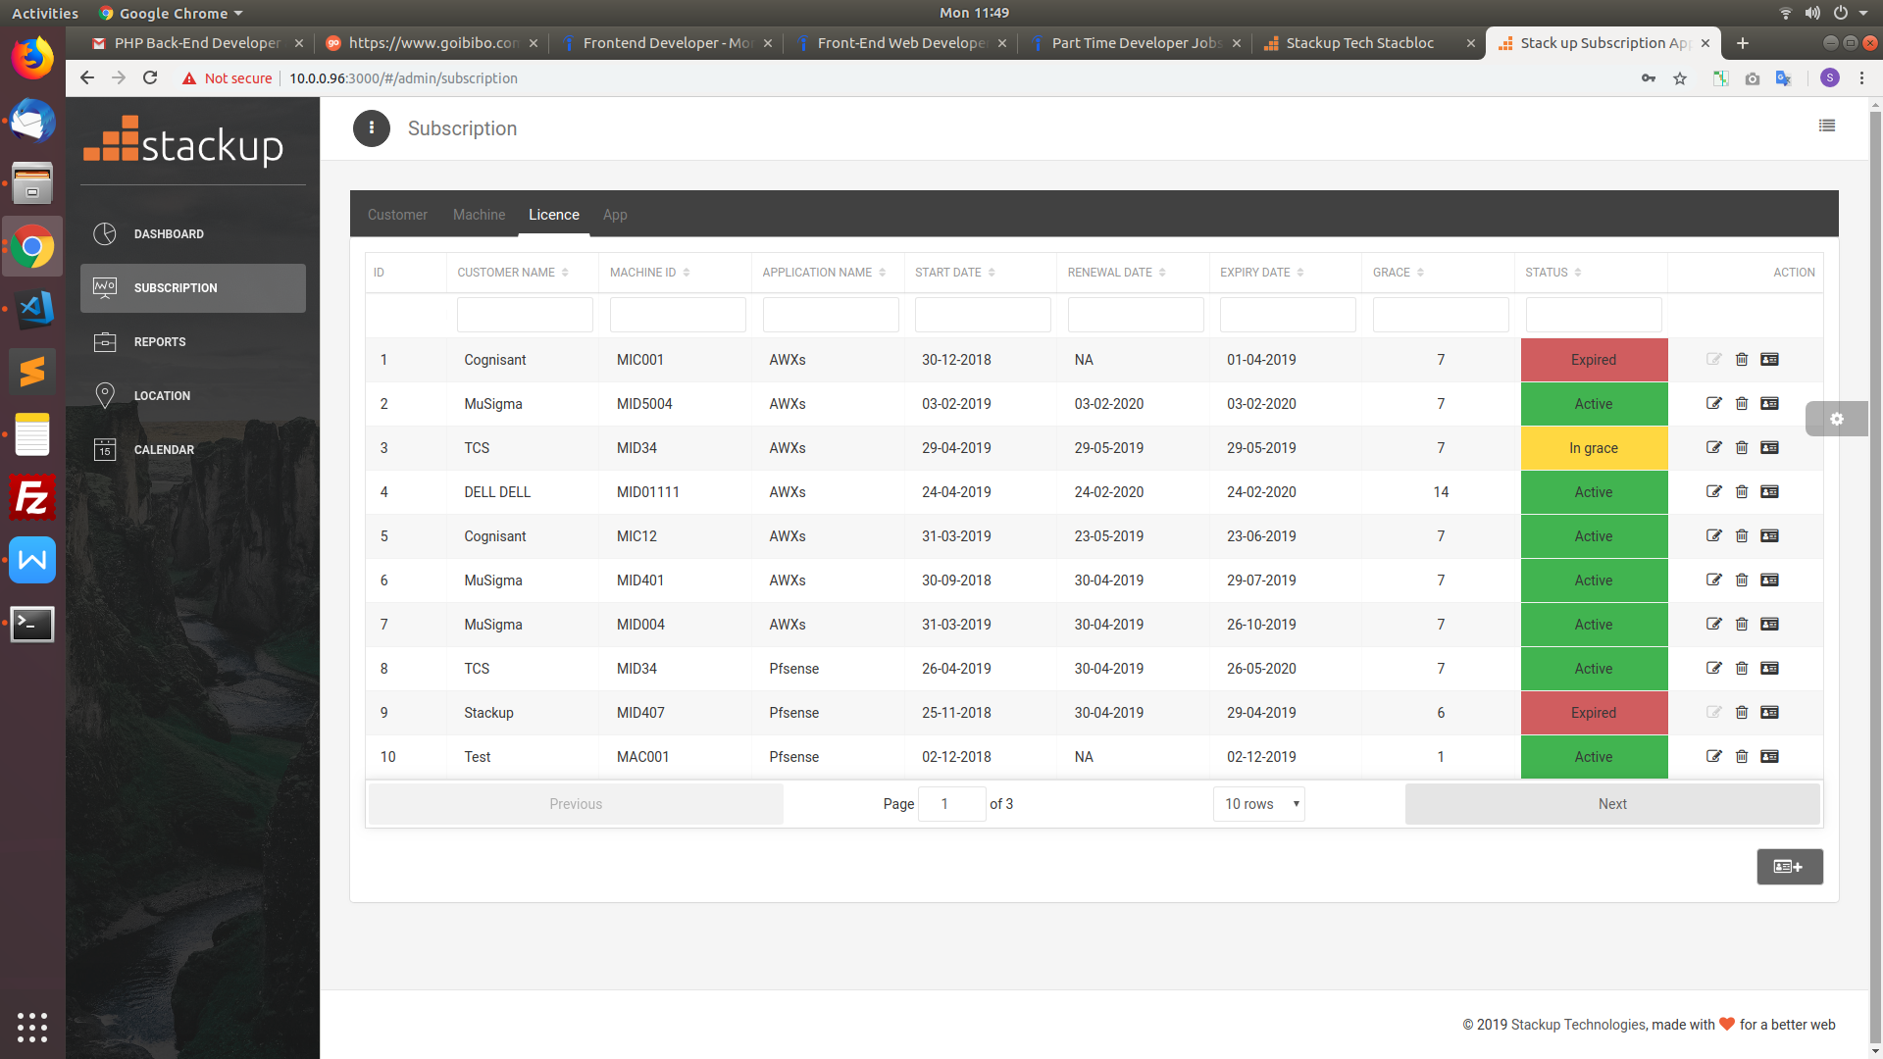

Edit -

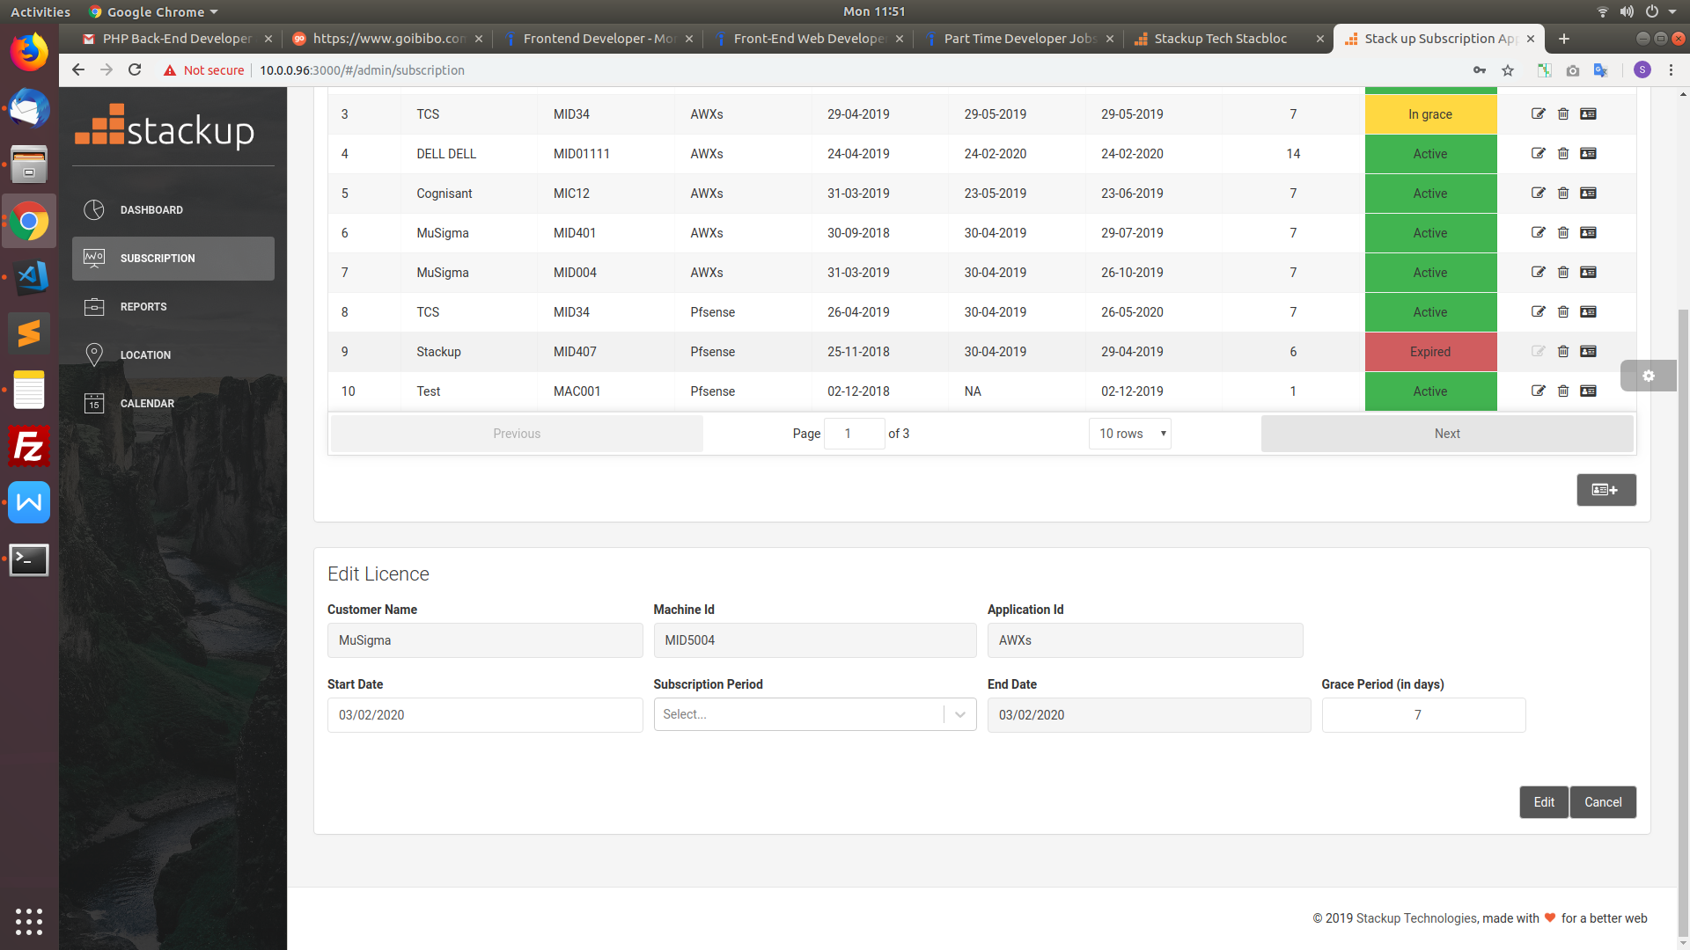

User can edit details of start Date , Subscription Period and Grace Period of the licence for ACTIVE status.

If the status is In grace and trial user can edit only grace period.

* Delete -

User can delete licence details just by giving confirmation to alert.

* Renew -

User can renew licence details ( subscription period and grace period) on click of Renew Button if the status is ACTIVE. 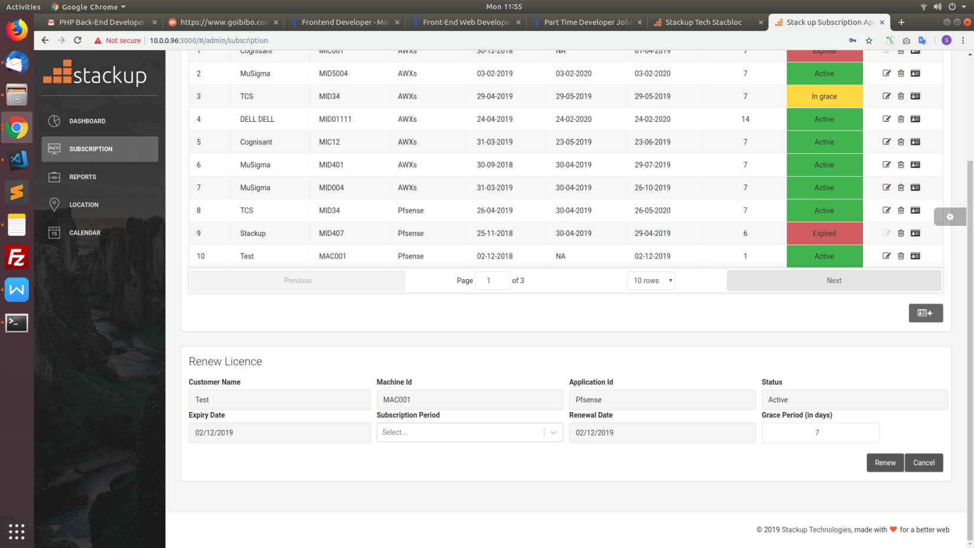

If the status is In grace or Expired or trial User can get to choose two option (Licence and Grace) which he/she can update accordingly.

**Adding Licence information:**



User can add licence details on click of plus button where he/she could choose to licence or trial.

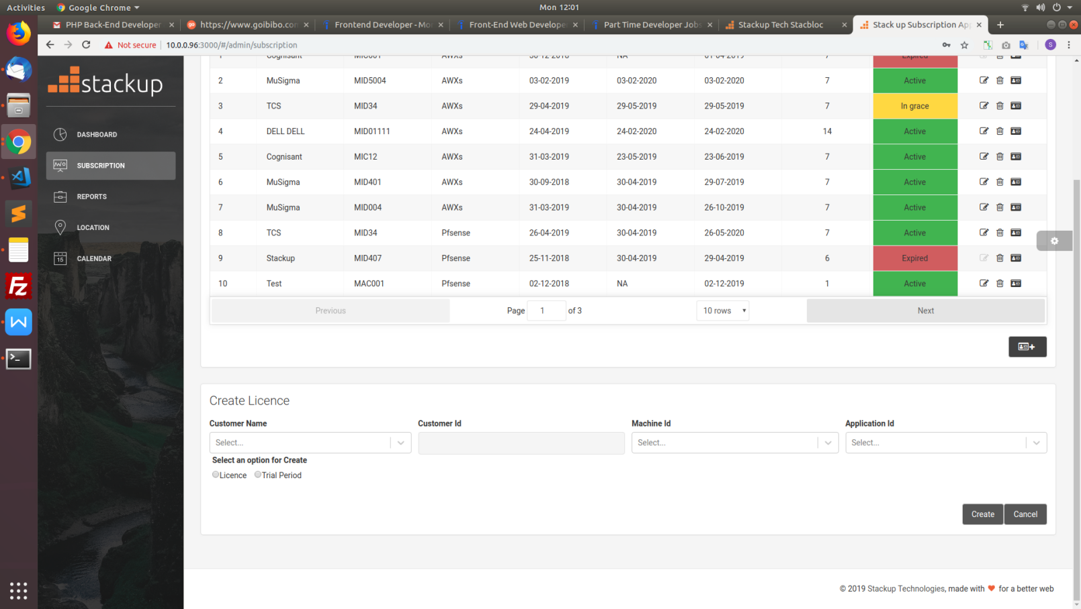

Licence - user should provide details of start date, subscription period and grace period.

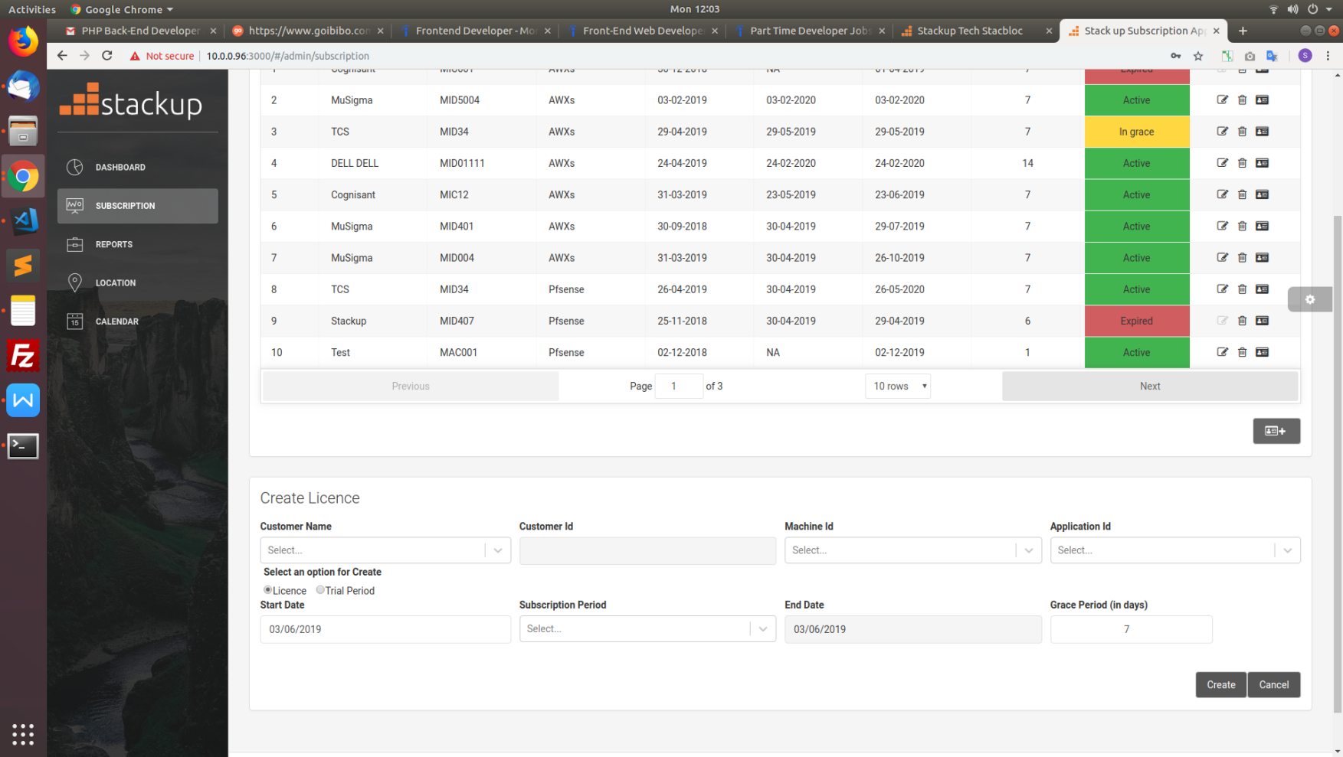

Trial - user should provide details of start date and grace period

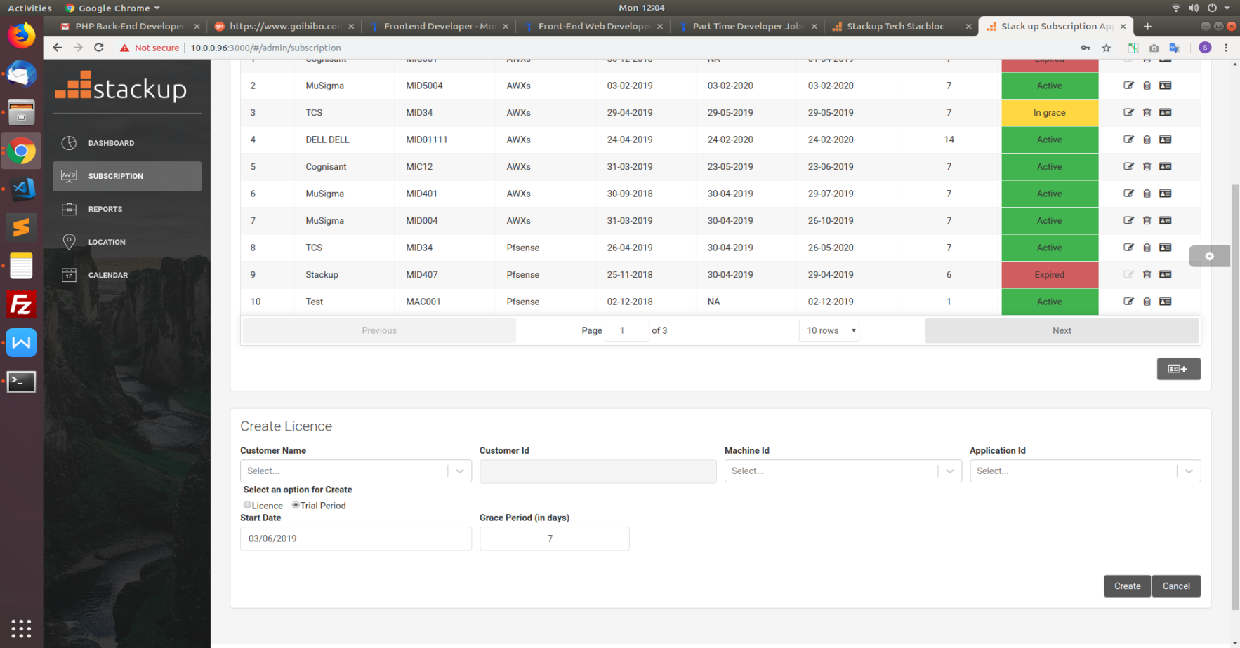

Click create button after filling up the details. Cancel to not to perform the action.

**4.5 App Tab**

This tab consists of data of the Application Name and actions to be performed in a table format.

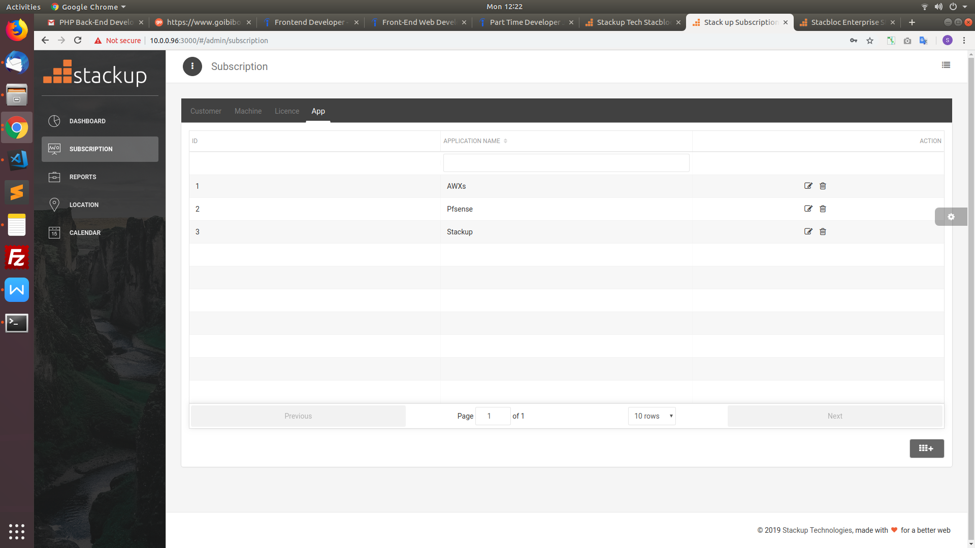

**Actions**

This page allows users to perform two actions namely **Edit, Delete**



* Edit -

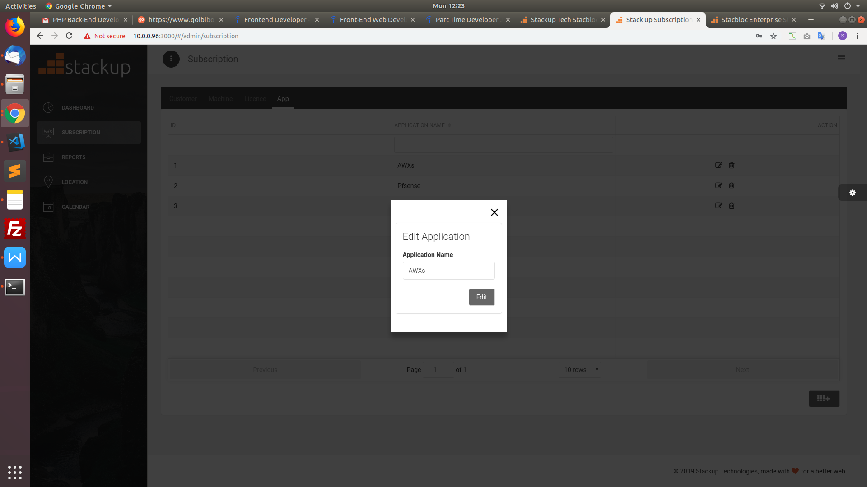

User can edit only Application details

* Delete -

User can delete application by giving confirmation to the alert.

**Adding Application information:**



User can add Application details on click of plus button.

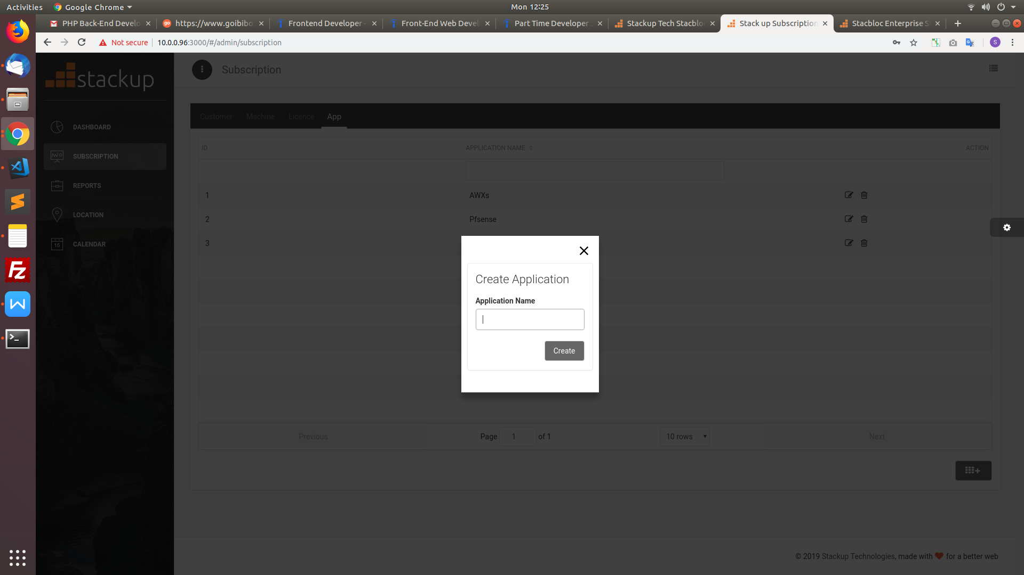

Click create after filling the application name.

**4.6 Functional flow**

**Creation of licence -**

The following steps guides to create the licence

* Creation of customer ( Tab 1 )-> 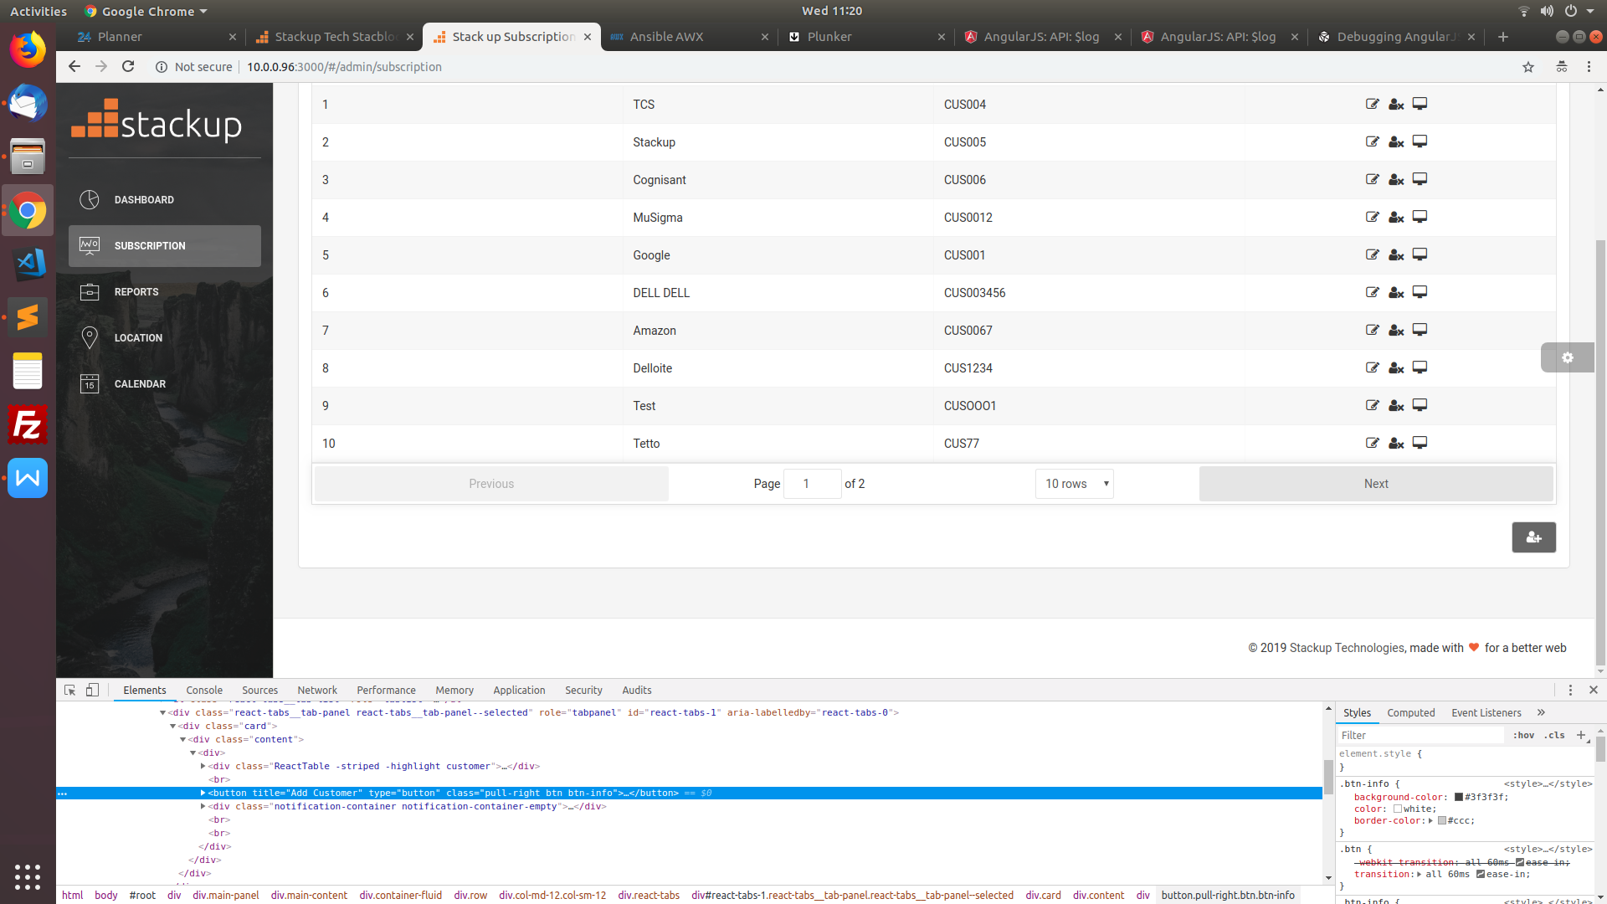 symbol proceeds to a pop up screen. Fill the details of the customer and save.
*  symbol of the created customer in the table redirects to Machine Tab where Machine ID details of the current customer can be created.
* Creation of Machine ID(Tab 2)-> 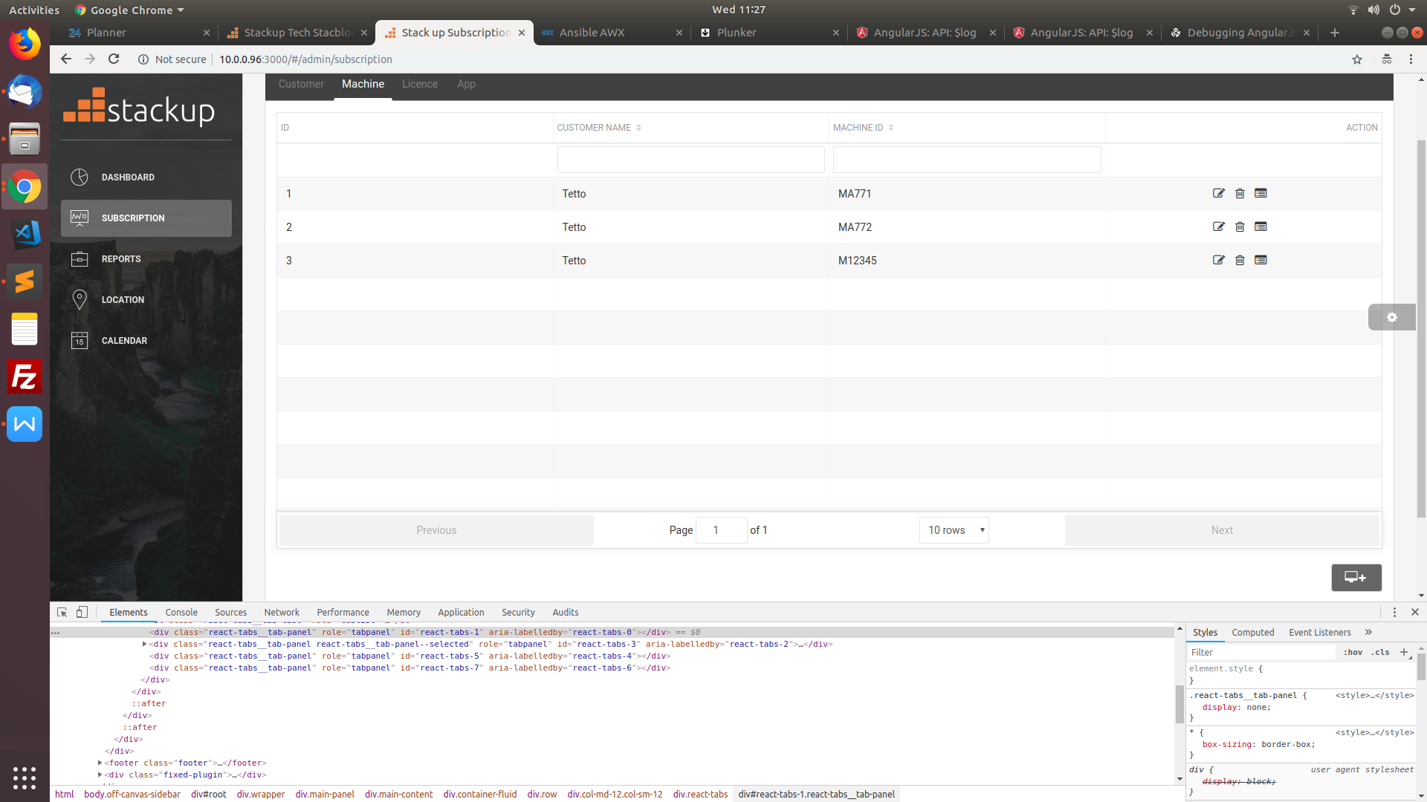 symbol proceeds to a pop up screen. Fill in the details of Machine ID and save.
*  symbol of the machine ID in the table redirects to Licence Tab where Licence Details of the specific machine ID can be created.
* Creation of App (Tab 4) -> 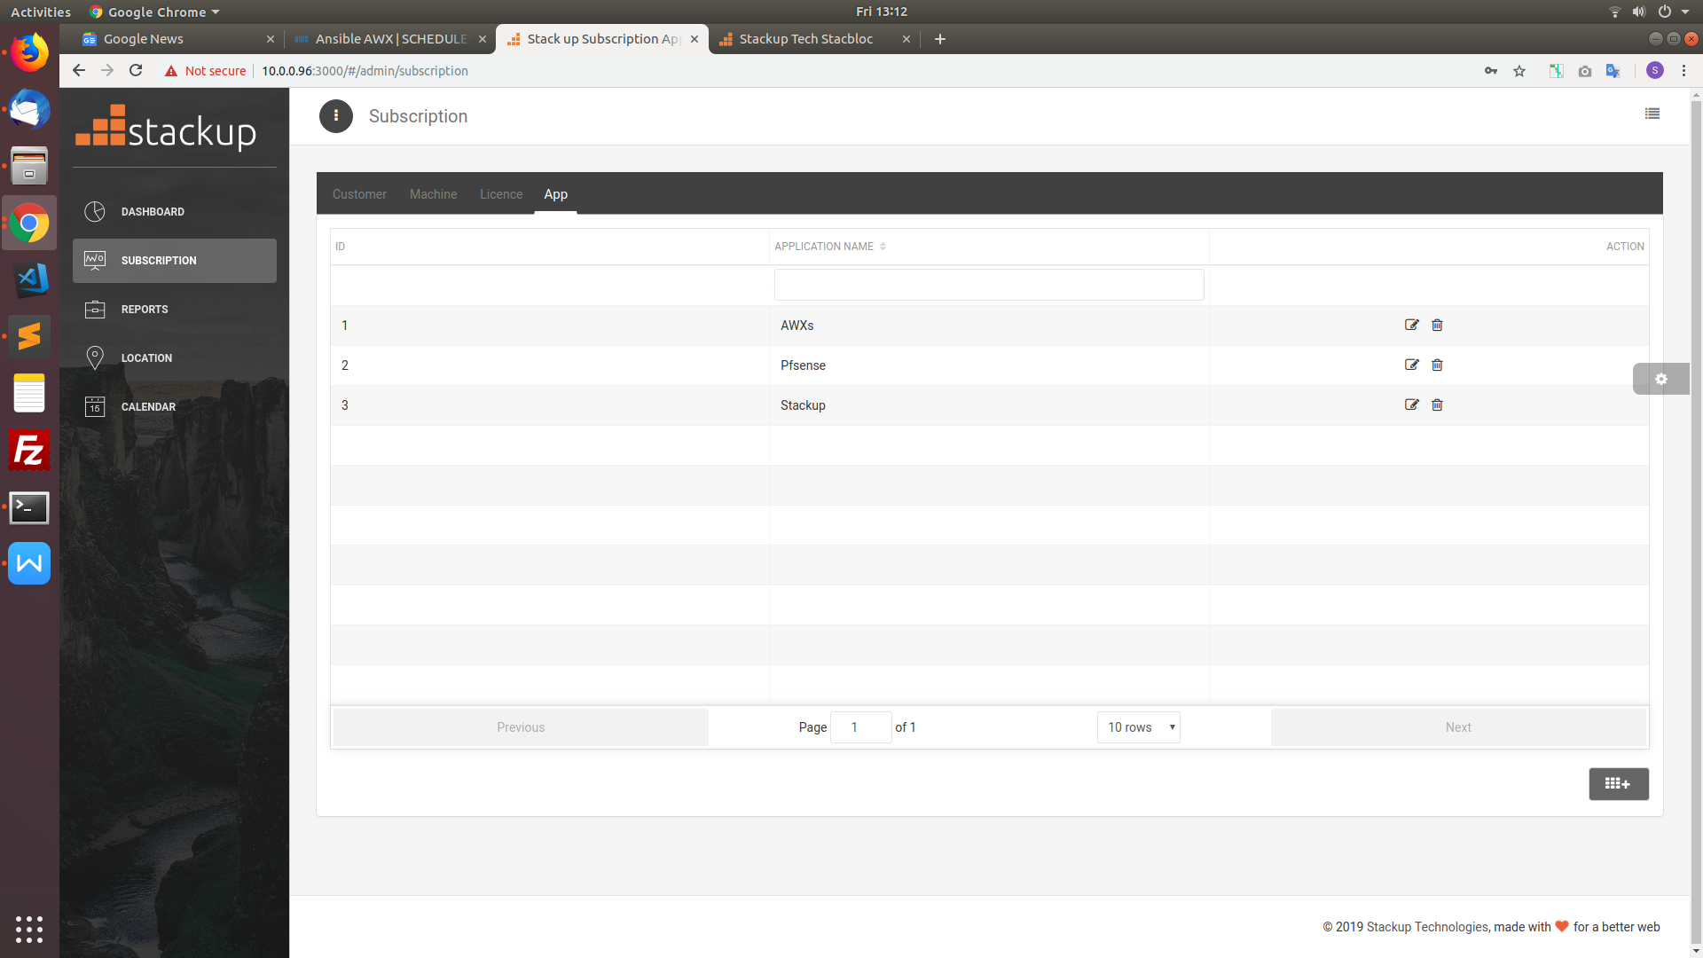 symbol proceeds to a pop up screen. Fill in the details of Application details and save.
* Creation of Licence(Tab 3) -> 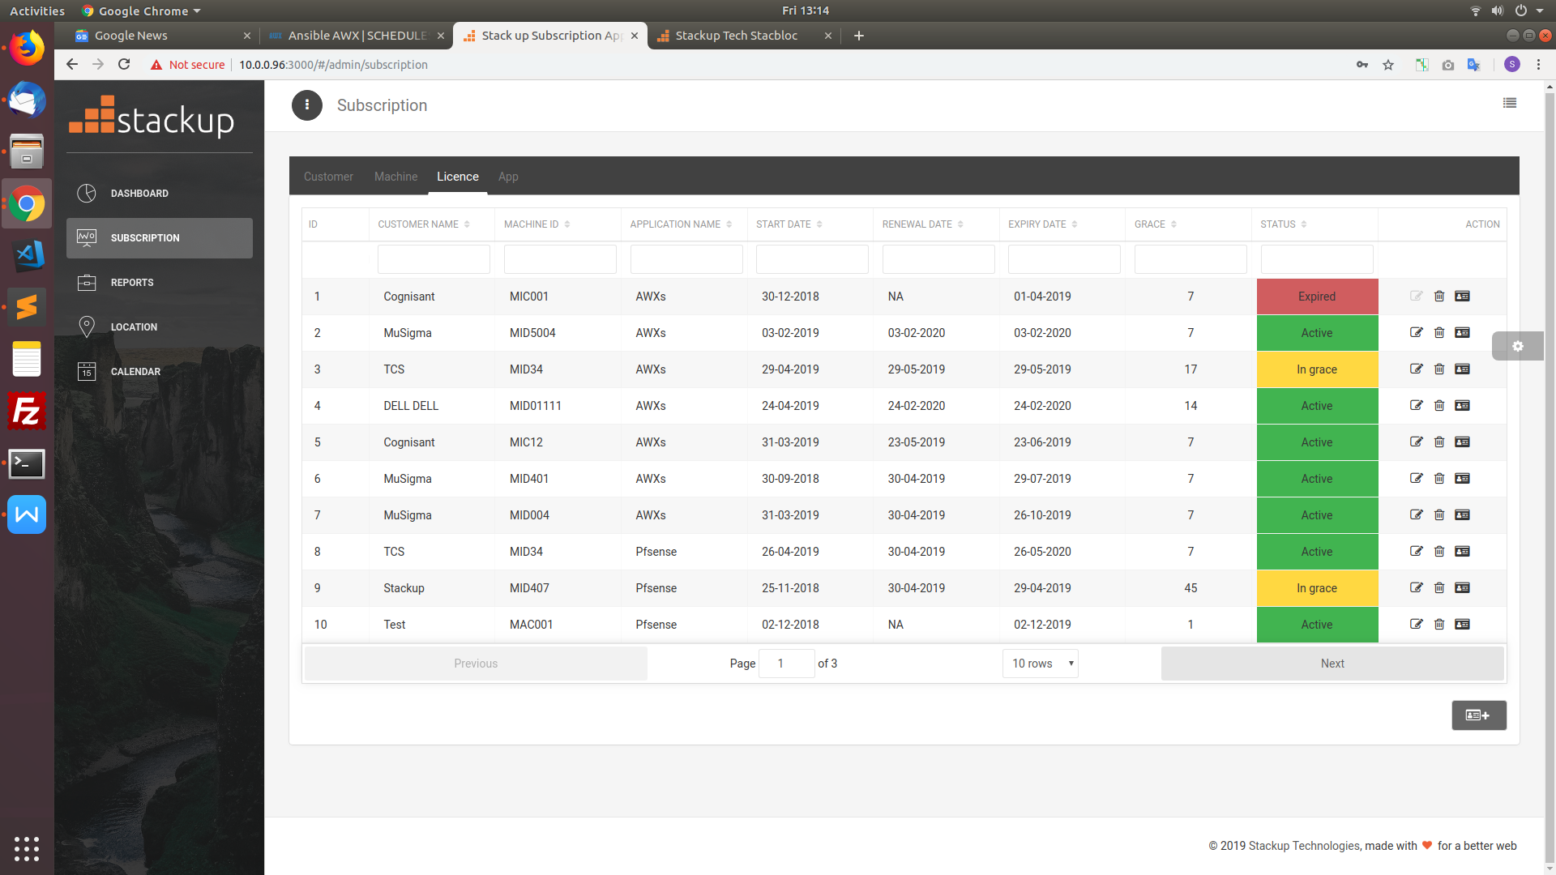 symbol opens a form beneath the table. Fill in the details of customer and corresponding machine ID, application with start date, subscription period of licence, grace period and save.
* The saved details will be visible in the table of licence. Use filter box to search in the column. 

**Renew licence -**

The following steps guides for renewing the licence (Tab 3)

* symbol in the table is used for renewing the licence.
* The button press will lead to a form at the bottom of the page which shows details of the customer, machine ID, application and status

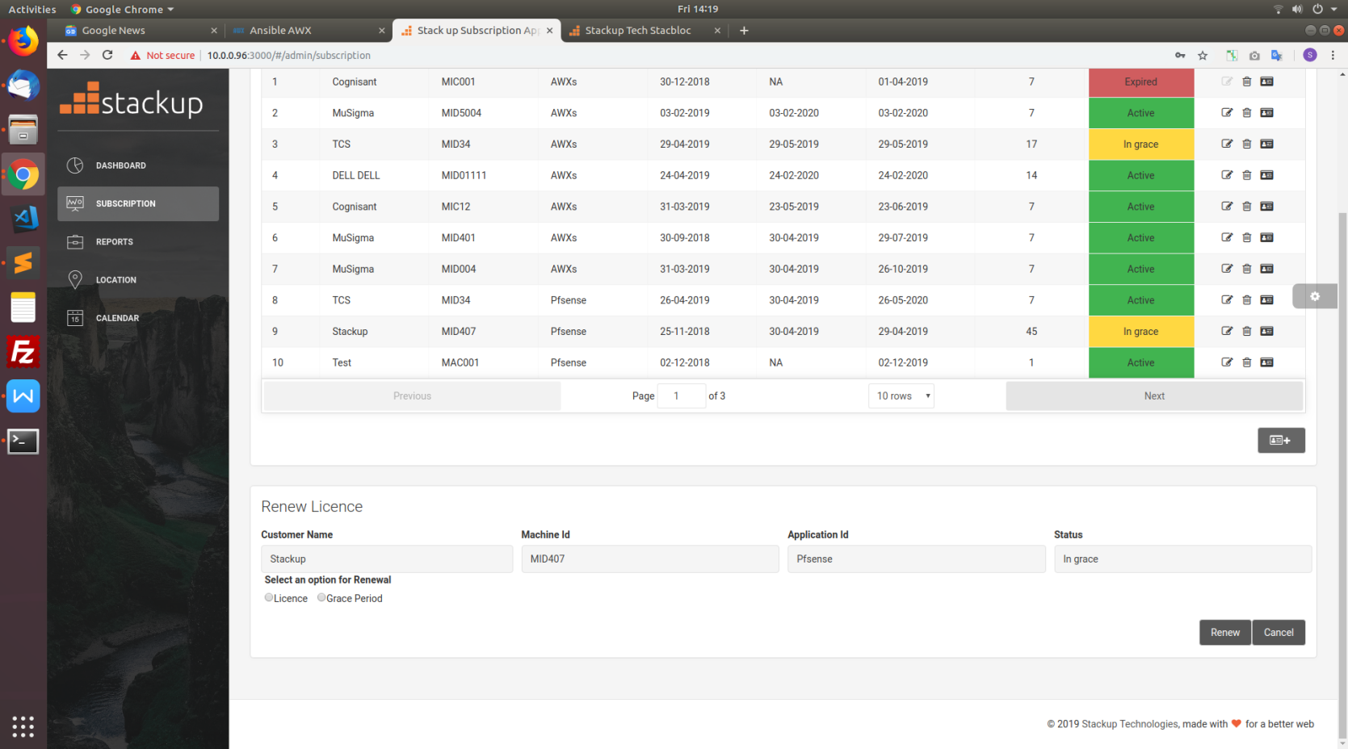

* Licence and Grace period can be renewed accordingly as per users accordance.

**5** **REPORTS PAGE**

It consists of two tabs (Report and Order)

**5.1 Report Tab**

This tab allows user to quickly view the report of licence details in a customized filter

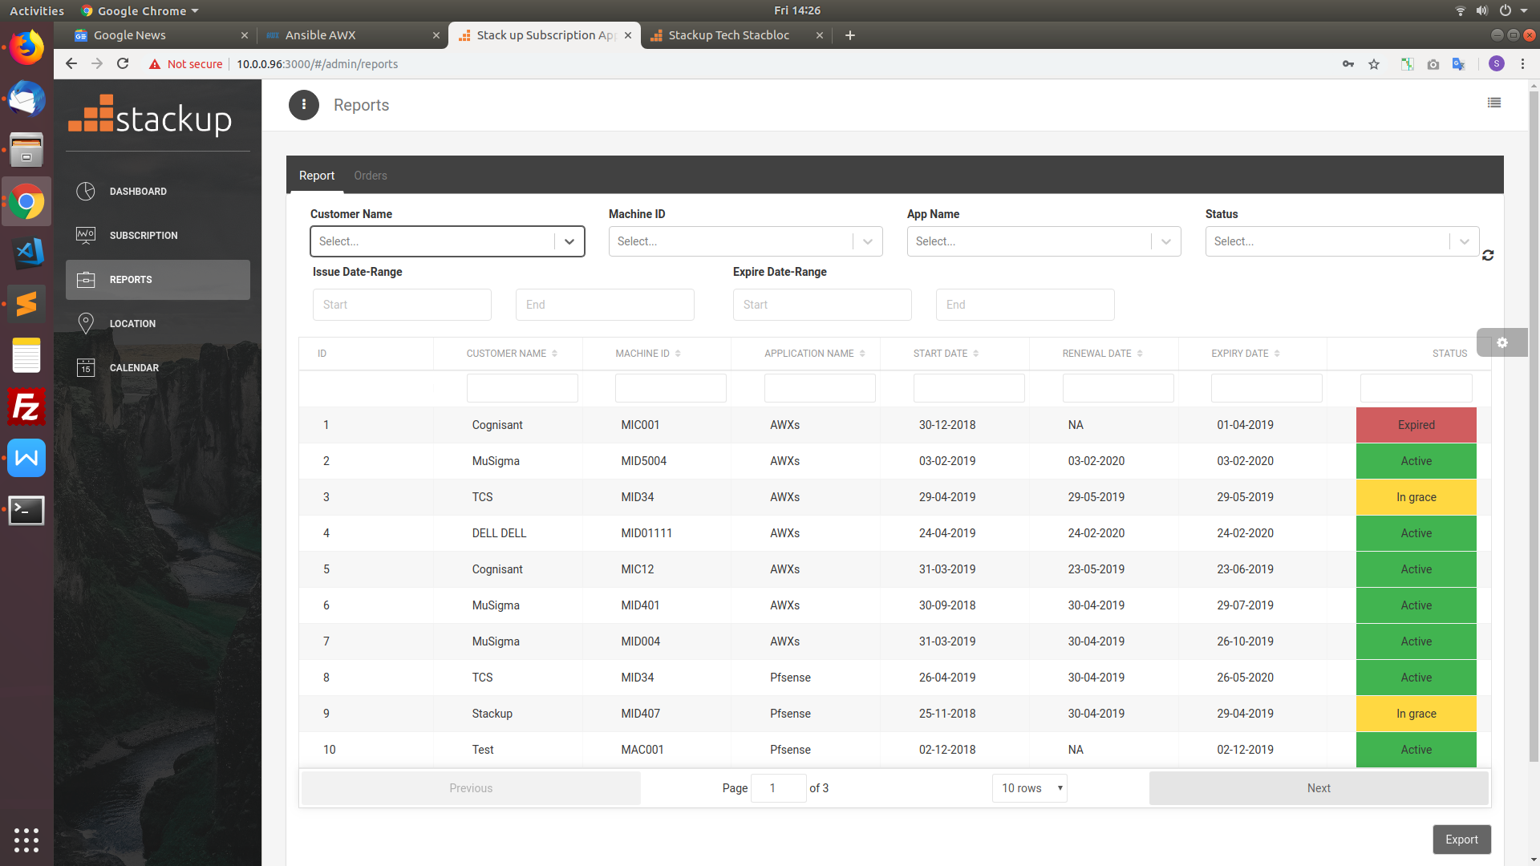

**Downloading Report**

You can download the Report by clicking the **Export** button. The downloaded file will opens in a spread sheet program

**5.2 Order Tab**

This tab allows user to quickly view the order of licence details in a customized filter

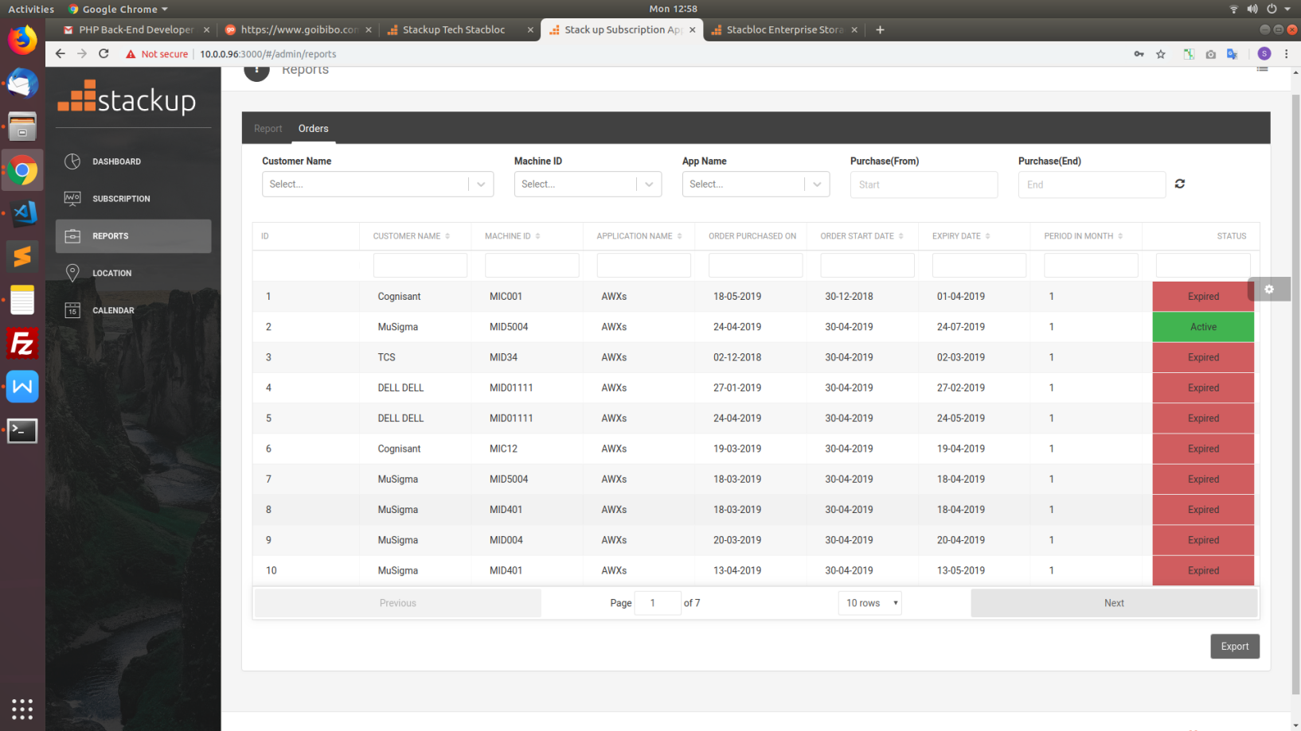

**Downloading Order Report**

You can download the Report by clicking the **Export** button. The downloaded file will opens in a spread sheet program

**5.3 Functional flow**

Report (Tab 1)-

The filter screen above the table allows user to select and get details specifically



* Customer Name shows a drop down box where user can select the customer for which the report has to be made.
* Accordingly machine ID drop down box shows machine IDs of the selected customer.
* App Name drop down box shows the details of all apps which can be chosen.
* Status drop down consists of Active, In grace, Expired, Trial which can selected by the customer accordingly.
* Issue Date-range is the date range where the user can select the (start and end) issue dates and get information in between the range respectively.
* Expire Date-range is the date range where the user can select the (start and end) expire dates and get information in between the range respectively.
* These filter details can be reset using the button with symbol 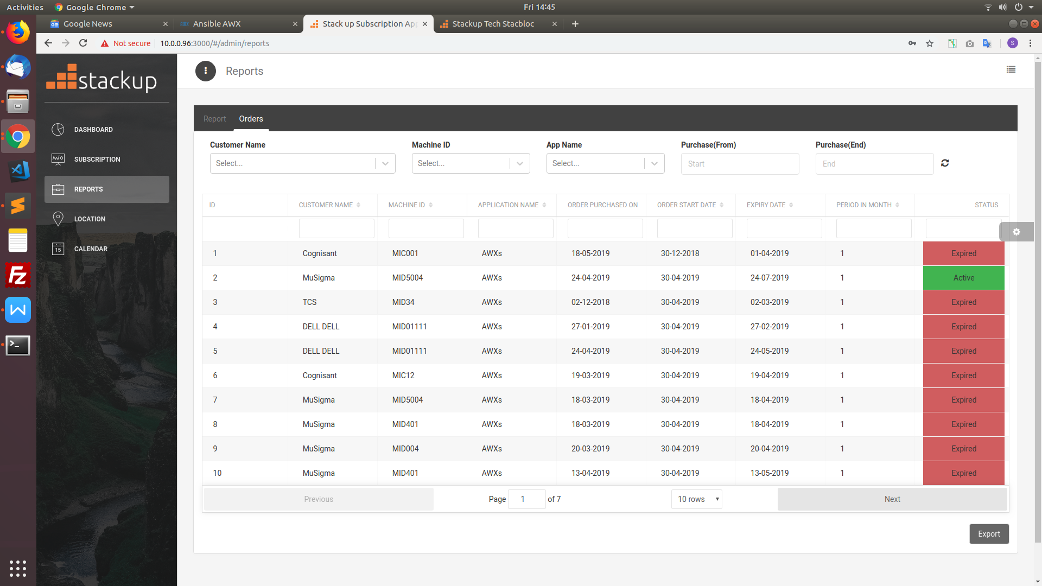

Order (Tab 2 )-

The filter screen above the table allows user to select and get details specifically.



* Customer Name shows a drop down box where user can select the customer for which the report has to be made.
* Accordingly machine ID drop down box shows machine IDs of the selected customer.
* App Name drop down box shows the details of all apps which can be chosen.
* Purchase(From) and Purchase(End) is the range in between the order purchased on date should be present which can be selected by the user.

**6** **LOCATION PAGE**

**6.1 Map**

The Location page allows users to quickly gain a bird’s eye view of all the locations relevant to the customer in a Map

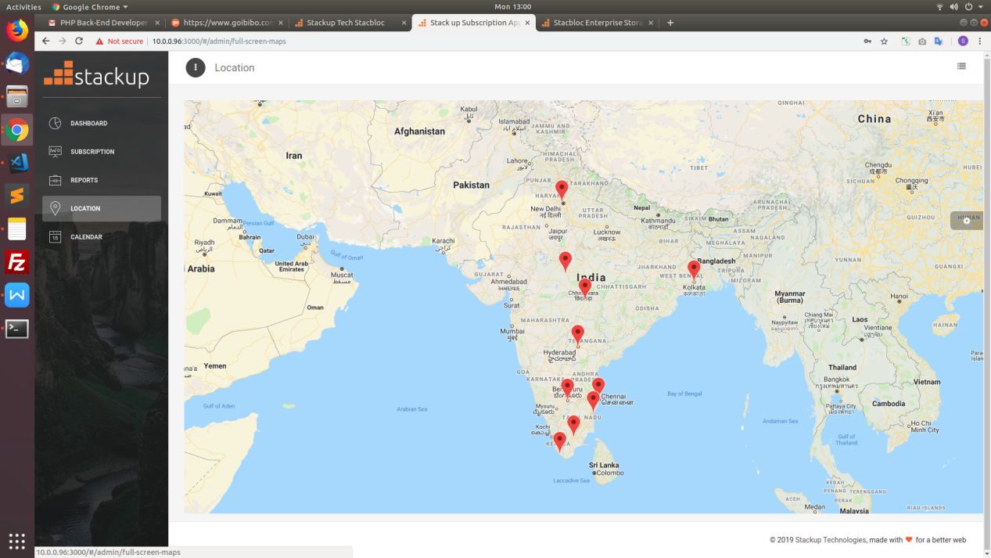

User can find out the customer Information on clicking the location Marker (red)

**7** **CALENDAR PAGE**

**7.1 Event Calendar**

In this page user can have a quick view on start date and expiry date of customers licence in the calendar format in three views(monthly, weekly, daily) as well as agenda.

* Red represents expiry date of the licence
* Green represents start date of the licence
* Grey represents event on that particular date

